**SECTION GF**

**FUEL INJECTION PUMP**

CONTENTS

|  |  |
| --- | --- |
| Description and Operation .. | chapter  1 |
| Fuel Injection Pump Troubles | 2 |
| Removal and Dismantling .. | 3 |
| Inspection | 4 |
| Assembly | 5 |
| Static Tests | 6 |
| Fuel Injection Pump Calibration | 7 |
| Fitting.. | 8 |
| Special Tools.. | 9 |
| Operation of High Pressure Trolley Set | 10 |

CHAPTER 1

DESCRIPTION AND OPERATION.

1. The function of the fuel injection pump is to:-
2. Raise the pressure of the fuel sufficiently for it to open the injector valve and spray a pre-determined amount of atomised fuel into the combustion chamber.
3. Deliver an equal amount of fuel to each cylinder.
4. Inject the fuel at precisely the correct moment for the most efficient combustion.
5. Vary the amount of fuel injected in accordance with the requirements of the engine at all conditions of load and speed.
6. The fuel injection pumps are of the individual type and are flange mounted to camboxes secured to the engine crankcase (Section GG). The pumps are controlled from the engine governor, mounted at the drive-end of the engine, via transverse and longitudinal linkage (Section HC).
7. Each pump is a cam operated, constant stroke, spring return plunger pump and comprises barrel (29)(Fig GF.14) and plunger (13), together with delivery valve (4) and seat (6), held in pump body by delivery valve holder (1). The plunger is operated by a cam follower assembly comprising tappet roller (23), roller pin (18), tappet (24) and lower spring plate (25). The lower spring plate is held in the tappet by plunger spring (14).

NOTE The plungers and barrels are manufactured to extremely fine limits and the working surfaces lapped together. For this reason, plungers and barrels are not interchangeable. This also applies to the delivery valves and seats.

1. Two grooves are machined in the bore of the barrel. Lower groove (37), which is supplied with lubricating oil from the engine main pressure circuit via drilling (38) in the pump body, both lubricates the plunger and forms a collar of high pressure oil against fuel leakage past the plunger and into the cambox. Upper groove (10) forms a collection point from which any fuel leakage past the upper portion of the plunger is returned to the fuel gallery.
2. The pump tappet, roller and roller pin are also lubricated from the engine main pressure circuit via oil drillings (17).
3. Tensile stresses induced by the pumping load are transferred from delivery valve holder (1) to pump body (15) by three high tensile studs (33), eliminating the high bursting forces from the upper part of the body.
4. The pump is arranged for a through flow of fuel, keeping operating temperatures down and allowing for a more consistent supply of fuel over a wide range of engine loads and speeds.
5. A spill plug (41) is screwed into the pump body directly facing the barrel fuel spill port. High pressure fuel spill from the barrel spill port (43) during the injection sequence is directed against the plug, any erosion taking place at the plug and not the pump body.

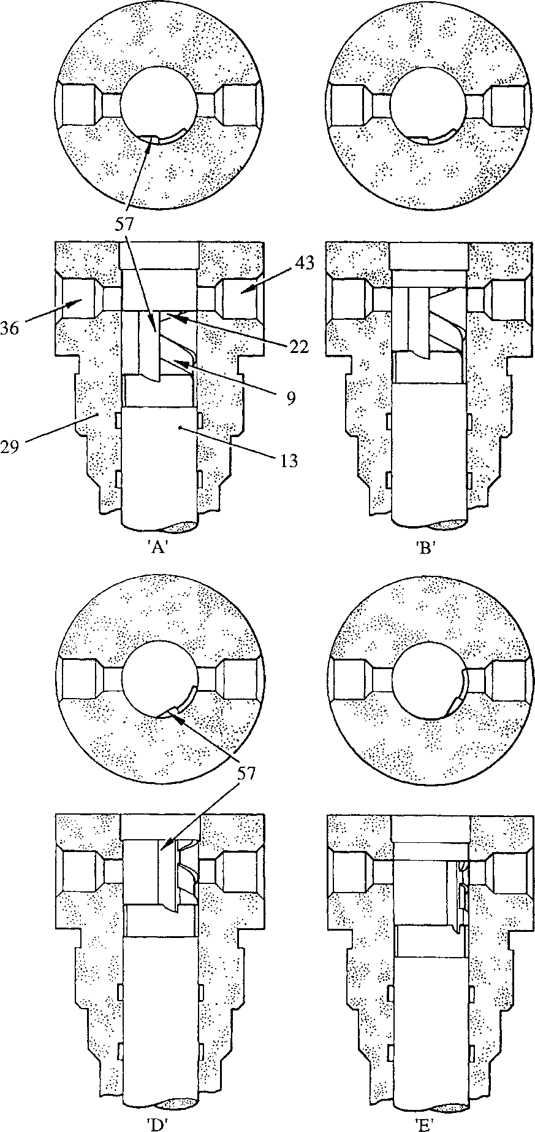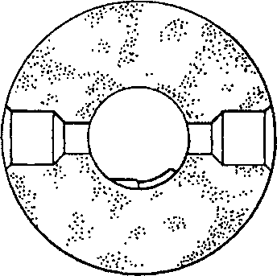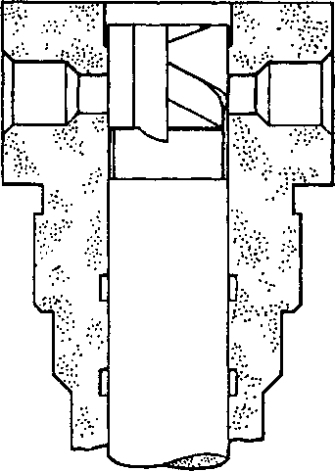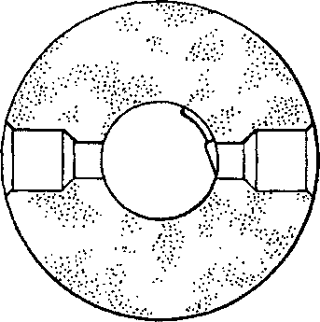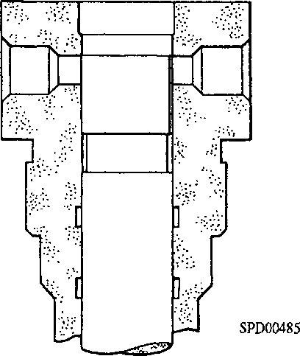

•c

T

Key to Numbers.

|  |  |  |  |
| --- | --- | --- | --- |
| 9. | Control helix groove | 36. | Fuel inlet port |
| 13. | Plunger | 43. | Fuel spill port |
| 22. | Retard helix groove | 57. | Vertical control slot |
| 29. | Barrel |  |  |

Fig GF.l Operation of fuel injection pump.

Operation.

1. The operation of a fuel injection pump element, ie. plunger and barrel, is shown diagrammatically in Fig GF. 1
2. At 'A', plunger (13) is in the full charging position and at the lowest limit of its travel so that fuel can enter barrel (29) by ports (43) and (36) from the fuel gallery in the pump. As the plunger rises, the fuel displaced by it is pushed back through the ports until the plunger reaches the position shown at 'B' where the top of the plunger has closed both ports.
3. The fuel above the plunger is then trapped and its only outlet is via the delivery valve. The pressure exerted by the rising plunger causes fuel to lift the valve and to enter the pipe connecting the pump to the injector. As the pipe is already full, extra fuel entering causes an instantaneous rise in pressure throughout the pipe, lifts the nozzle valve of the injector and permits fuel to be forced into the engine combustion chamber in the form of a fine spray. At the moment fuel is being pumped into the pipe at the pump end, an equal amount is being forced out at the injector end. This continues until the plunger reaches the position shown at 'C'.
4. At this point, the upper edge of control helix groove (9) has uncovered fuel spill port (43), allowing fuel to be by-passed from the barrel to the fuel gallery, which is under a very much lower pressure than the fuel above the plunger, via vertical slot (57) and the control helix groove. This allows the delivery valve to shut under the action of its spring and, with the consequent collapse of pressure in the pipeline, the injector nozzle valve also shuts.

Control of Output.

1. The plunger stroke is always constant but, as the plunger itself can be rotated within the barrel, the point in the stroke at which pumping starts is controlled by retard helix (22) and at which it finishes by control helix (9).
2. The plunger is shown rotated to the half load position at 'D', whilst at 'E' it is in the idling position. To stop the engine, the plunger is rotated to the position shown at 'F, so that vertical slot (57) coincides with the barrel port during the whole of the plunger stroke and no fuel is delivered.
3. The plunger is rotated by control sleeve (ll)(Fig GF.14), locating pin (16) rivetted to the lower end of the plunger, engaging with a slot in the sleeve. Rotation of the sleeve is by control rod (27), the teeth machined on both items forming a rack and pinion.
4. The retard helix groove (22)(Fig GF.l) in the plunger, effectively allows for variation in the control of the point of injection at lower engine speeds.

Unloading Device.

1. The delivery valve has a second important function. A small collar formed on the stem of the delivery valve acts as a piston in the seat bore whilst the valve is closing. This has the effect of withdrawing or unloading a specified volume of fuel from the injector pipe, thereby suddenly reducing the pressure so that the injector nozzle valve can snap back on to its seat and terminate the spray of fuel into the combustion chamber without 'dribble'.

CHAPTER 2

FUEL INJECTION PUMP TROUBLES.

Fuel injection difficulties can arise from several causes, some of which may be traced to the injection pumps. Such difficulties, with their likely causes and remedial action, are set out in the table below. Many of the difficulties in the table can be attributed to dirt reaching the pumps. Fuel filters should be cleaned regularly and thoroughly, and if the fuel supply pipes have been disconnected utmost care should be taken to ensure that they are thoroughly clean by washing through with CLEAN fuel oil of the correct grade immediately before reconnecting.

CAUTION PUMP SERVICING MUST NEVER BE ATTEMPTED ON THE ENGINE. PUMPS SHOULD BE REMOVED AND RETURNED TO A FUEL INJECTION PUMP ROOM FOR SERVICING.

|  |  |  |
| --- | --- | --- |
| SYMPTOM | FAULT | REMEDIAL ACTION |
| Appearance of fuel at pump or injector nut | Injection pipe leakage | Check nuts are not loose. Remove pipe and check pipe olives, injector and pump seatings for damage. Renew defective pipes |
| Fuel leakage between delivery valve holder and pump body. (If leakage is internal, it will only be shown by incorrect exhaust | High pressure seal leakage | Fit replacement pump and return defective unit for servicing. |
| temperature.) |  |  |

NOTE In an emergency it is permissible to change the high pressure seal and or 'O' ring if an unacceptable level of leakage occurs provided: -

1. Care is taken to tighten the delivery valve holder correctly in accordance with paragraph 5.14.
2. A replacement pump is fitted as soon as possible, and the faulty pump returned for servicing

Exhaust temperatures incorrect

Lubricating oil leakage from under pump flange

Incorrect control rod setting

Incorrect calibration Control rod jammed

Damage to non-return valve or/and pump to cambox 'O' rings

Shim under pump damaged

Check and reset (Section HC)

Remove pump and re-calibrate

Fit replacement pump and return defective unit for servicing

Remove pump and renew 'O' rings as necessary

Remove pump and renew shim

|  |  |  |
| --- | --- | --- |
| SYMPTOM | FAULT | REMEDIAL ACTION |
| Lubricating oil collecting in protective bellows over end of control rod | Control rod oil seal damaged | Fit replacement pump and return defective unit for servicing |
| Fuel injection pump excessively noisy | Blocked fuel injector leak off | Fit replacement injector and return defective unit for servicing |
|  | Broken plunger spring. Broken tappet roller | Fit replacement pump and return defective unit for servicing |
| No pump noise | Pump plunger seized. Tappet seized. Control rod jammed in zero fuel position | Fit replacement pump and return defective unit for servicing. Before fitting new pump, check lubricating oil flow through cambox to pump position |
| Fuel delivery not uniform. May be shown by fluctuating exhaust temperature | Delivery valve spring broken or damaged delivery valve and/or seat | Fit replacement pump and return defective unit for servicing |
| Excessive combustion noise from cylinder | Fuel pump timing incorrect | Check and re-time |

CHAPTER 3

REMOVAL AND DISMANTLING

Removal

1. Remove the covers over the fuel injection pump control linkage (Section HC).
2. Turn off the fuel supply, drain the fuel system and remove and blank off the fuel supply pipes between the injection pump and the upper and lower gallery rails.
3. Remove sheathed fuel injection piping. Refer to removal procedures for sheathed fuel piping in Section GJ.
4. Release return springs (119)(Fig GF.12) and remove forked end lever (120) from the longitudinal shaft.
5. Remove philidas nuts (116) and withdraw the pump from engagement with the cambox. Remove laminated shim (112), oil transfer ferrule (110) and 'O' rings (113).
6. Fit a protective cap to the outlet to fuel injector (5)(Fig GF.14), and protective plugs to the inlet and return connections. Blank off the lubricating oil drillings in the pump flange and spigot with masking tape.

Dismantling.

1. Dismantling should not be lightly undertaken as only personnel trained for fuel injection equipment can be expected to carry it out with any success. Strict cleanliness must always be observed, care being taken to see that all filings, dirt, grit, dust, etc. are removed from the bench on which the work is to be done. The bench should be covered with a sheet of zinc or linoleum, or similar easily cleaned material. It is also necessary to have a number of thoroughly clean, covered vessels available to hold a supply of clean fuel oil for washing the dismantled parts.
2. During dismantling operations the components of each individual pump should be kept together, and it is especially important that pump plungers are only fitted to barrels with which they were originally mated. Similarly the delivery valve should only be assembled with its original seat. The surfaces of the element assembly (barrel and plunger), the delivery valve and internal surfaces of the seat must never be touched with a file, scraper or other hard tool, or any abrasive compound. Should the element assembly, or delivery valve assembly be damaged or faulty in any way, they should be renewed. It is permissible to lightly lap the mating face of the delivery valve seat (Fig GF.4) adjacent to the barrel to remove minor imperfections to 0.01 mm maximum prior to fitting a new plunger assembly.
3. To facilitate dismantling, special fixtures are necessary. These special fixtures and their Reference Nos are listed in Chapter 9.
4. Release philidas nut (124)(Fig GF.12), and remove adjusting screw (122), bellows (126), and adaptor (125) from the end of control rod (27)
5. Release setscrews (55) and (51)(Fig GF.14) and remove retaining plate (53), complete with oil seal (52). DO NOT RELEASE CHEESEHEAD SCREW (54) SECURING SHIMS (56) TO RETAINING PLATE (53).
6. Bolt jacking screw fixture (61)(Fig GF.2) to the pump flange and place the pump and fixture in an inverted position on the arms of support fixture (62).
7. Bend back tabwasher (20)(Fig GF.14) and remove locking screw (21).
8. Swing the jacking screw (60)(Fig GF.2) into position, locate the rim of pressure plate (59) on the tappet body and tighten the jacking screw to depress the tappet sufficiently to remove the load on the roller pin locating dog (58). Press the roller pin dog (58) out of engagement with the pump body until the end is flush with the tappet as shown in inset.
9. Release the jacking screw until the tension of plunger spring (14)(Fig GF.14) is released, and swing clear of the pump. Lift out tappet (24)(Fig GF.2) complete with tappet roller (23) and roller pin (18). Press out the pin and withdraw the roller from the tappet.
10. Withdraw lower spring plate (25)(Fig GF.14) together with attached pump plunger
11. . Care must be taken not to drop the plunger or to burr the top (control) edge of the plunger by contact with the spring or pump body. Disengage plunger from the lower spring plate and place in a tray of clean fuel.
12. Lift out plunger spring (14). Withdraw control sleeve (11), together with upper spring plate (26) and its retaining circlip (12). Withdraw control rod (27).
13. Remove the jacking screw fixture complete with pump from the support fixture. Remove the pump from the jacking screw fixture and secure to the Stroke To Port Closure (STPC) fixture (Fig GF.3).

NOTE The face of the spigot together with high pressure seal (7)(Fig GF.14) forms the pump high pressure seal. Damage to the spigot face will necessitate delivery valve holder renewal.

1. Release nuts (35)(Fig GF.14) evenly and a little at a time and lift off delivery valve holder (1). Remove 'O' ring (32) and backing ring (65), but do not remove spring peg (2) unless it is loose. Place the holder in a safe place in an inverted position. If possible, fit a protective cap.
2. Remove delivery valve spring (3) and delivery valve (4). Withdraw delivery valve seat (6) together with high pressure seal (7) and support ring (31). Place the delivery valve and seat in a bath of clean fuel oil.
3. Remove setscrews (48) and stop plate (46).

NOTE After the barrel locating screw (40) has been removed, the only item holding barrel (29) in position is 'O' ring (28).

1. Break the locking wire and remove spill plug (41), copper washer (42), barrel locating screw (40) and 'O' ring (39).
2. Remove pump body from the STPC fixture and place in an inverted position on the bench. Place a piece of aluminium between the pump studs (33) to prevent damage to the pump barrel when it drops out and then tap the lower end of the barrel with a clean soft drift to remove. Remove and discard 'O' ring (28).

CHAPTER 4

INSPECTION.

1. Element Assembly. After prolonged service, erosion may be evident on the plunger approximately one port diameter above the control helix in the full fuel position. This will not detract from the pump performance providing the erosion does not encroach to within 1 mm of the control helix edge. Erosion may also be found 180° round the plunger to that above the helix, and is referred to as blind erosion. This is not detrimental to pump performance.
2. Plunger/barrel wear cannot be determined by visual inspection or measurement. Pump output measured on a test rig is the only method of determining wear. However, the wearing surfaces must be examined for scoring, pitting and erosion etc, and if such faults are evident the complete element assembly must be renewed.
3. Check that plunger locating pin (16)(Fig GF.14) is tight in the plunger. If any looseness can be detected the pin MUST be re-rivetted. This requires special equipment and it is recommended that the components are returned to the manufacturers for servicing. If return is not practicable, re-rivetting can be carried out with a hammer or press, but it is essential that the flats on the pin are maintained precisely parallel with the plunger, and that the surfaces of the plunger are not damaged during re-rivetting.
4. Barrel locating screw (40). Check the locating portion of the screw. Damage to this portion could result in poor location of the barrel. If suspect, fit a new screw.
5. Spill plug (41). Erosion caused by fuel spill is normally taken on the plug and NOT the pump body. If excessive erosion damage has occurred, fit a new plug. If pump body erosion has also taken place and has progressed to four (4) threads FROM the fuel gallery face, the pump body should also be renewed.
6. Delivery valve holder (1). Examine conical face for erosion (pitting), signs of leakage (irregular radial tracks) or other damage. Owing to the different angles between the conical face and high pressure seal (7), the actual seating is at the bore. If any of the above faults are evident the delivery valve holder should be renewed. If the faults are only marginal in appearance, the holder can be refitted and special care taken over the high pressure test. Check spring peg (2) for damage or wear, but do not remove unless the peg is loose in its bore.
7. High pressure seal (7). Examine for erosion (pitting), and signs of leakage (irregular radial tracks). If these faults are evident renew the seal. Due to spread of the high pressure seal it may be necessary to drive support ring (31) off delivery valve seat (6). If this is the case the seal will be distorted and MUST BE RENEWED.
8. Delivery valve/seat assembly. Check that delivery valve (4) is a free sliding fit in the delivery valve seat (6) and that both components are free from damage. Examine the valve seat for erosion and leakage markings at the contact surfaces with high pressure seal (7). Renew the delivery valve assembly if badly marked. The bottom mating face of the delivery valve seat (6) may be lightly lapped on the lapping plate (Fig GF.4) to restore the seal and to remove minor imperfections. Examine delivery valve spring (3) for corrosion or collapse.

24 23

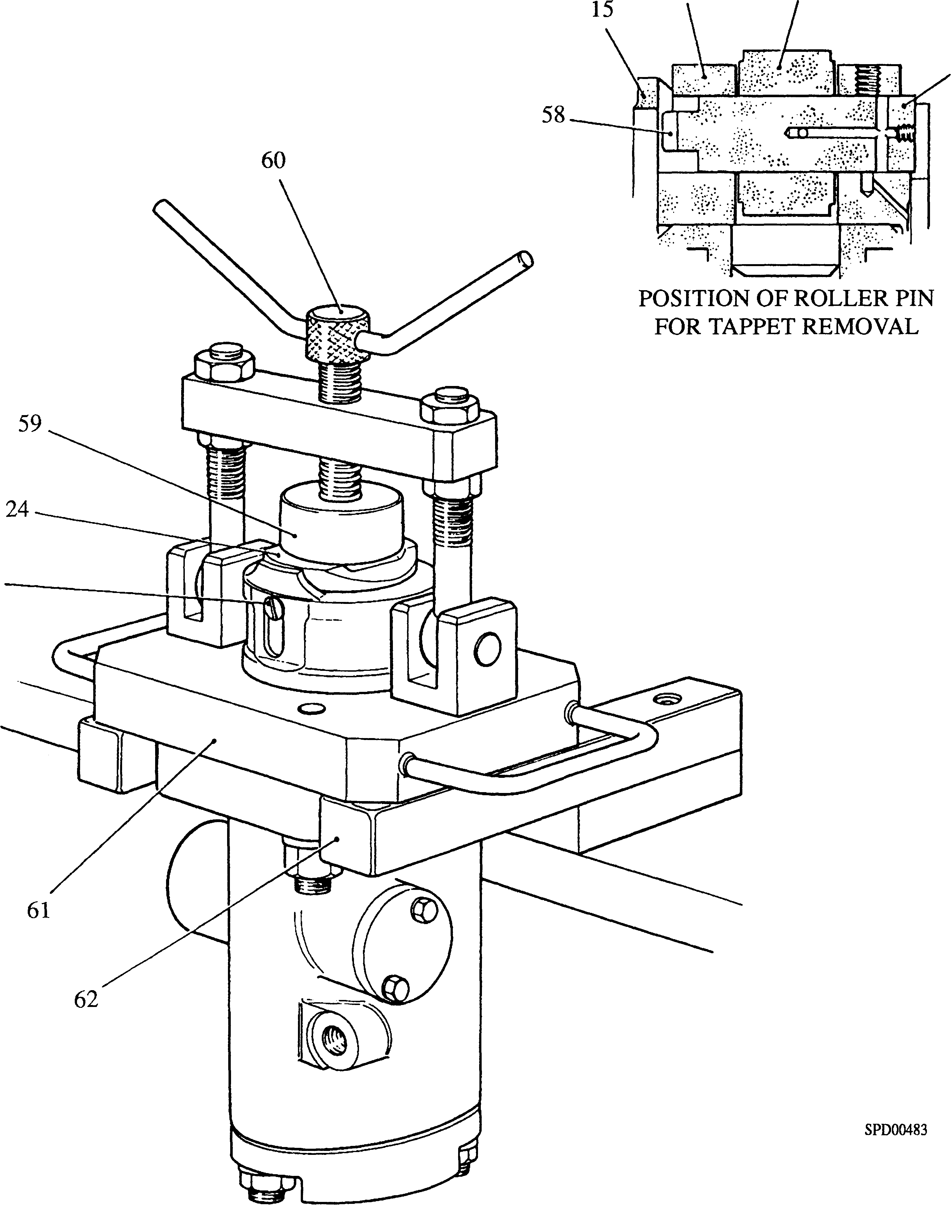

|  |  |  |  |
| --- | --- | --- | --- |
| Key to Numbers. | |  |  |
| 15. | Pump body | 59. | Pressure plate |
| 18. | Roller pin | 60. | Jacking screw |
| 23. | Tappet roller | 61. | Jacking screw fixture |
| 24. | Tappet | 62. | Support fixture |
| 58. | Roller pin locating dog |  |  |

**Fig GF.2 Tappet removal and fitting.**

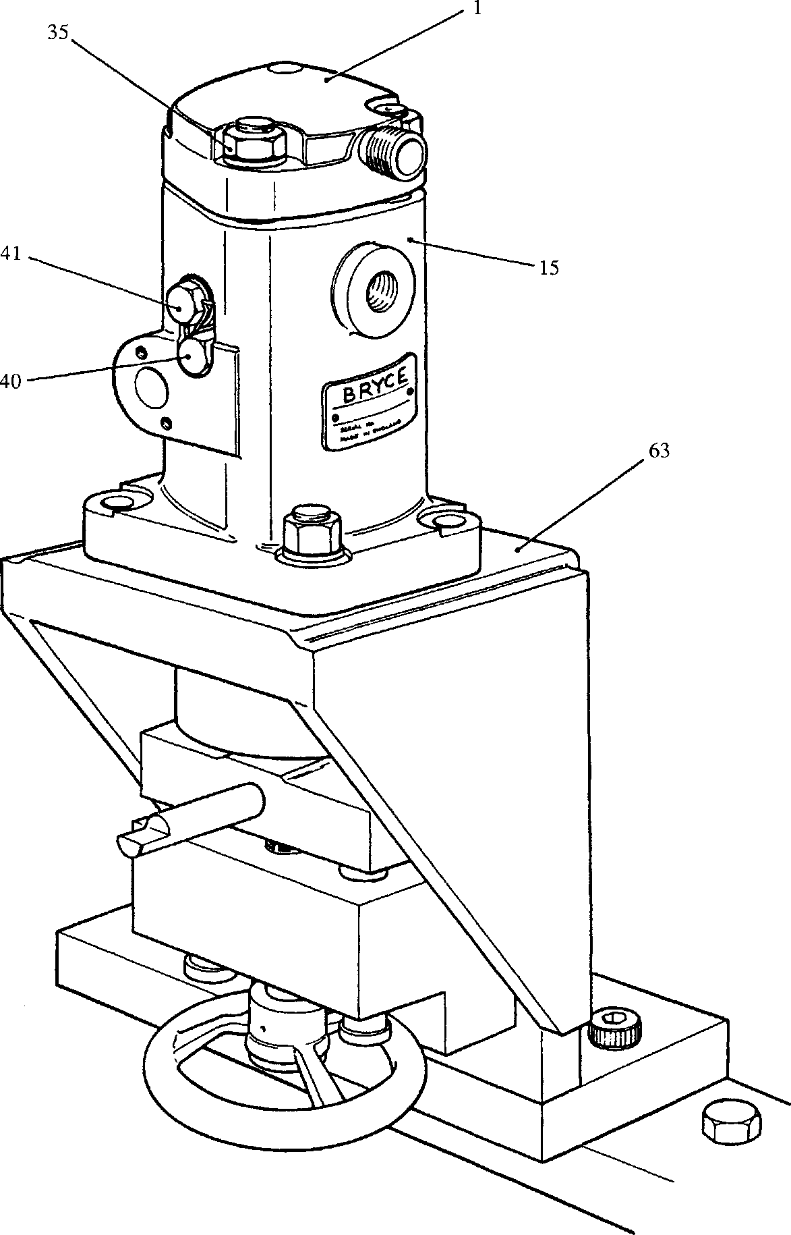

**SPD00473**

Key to Numbers.

|  |  |  |  |
| --- | --- | --- | --- |
| 1. | Delivery valve holder | 40. | Barrel locating screw |
| 15. | Pump body | 41. | Spill plug |
| 35. | Nut | 63. | STPC fixture |

Fig GF.3 Pump mounted to STPC fixture for dismantling and assembly

Key to Numbers.

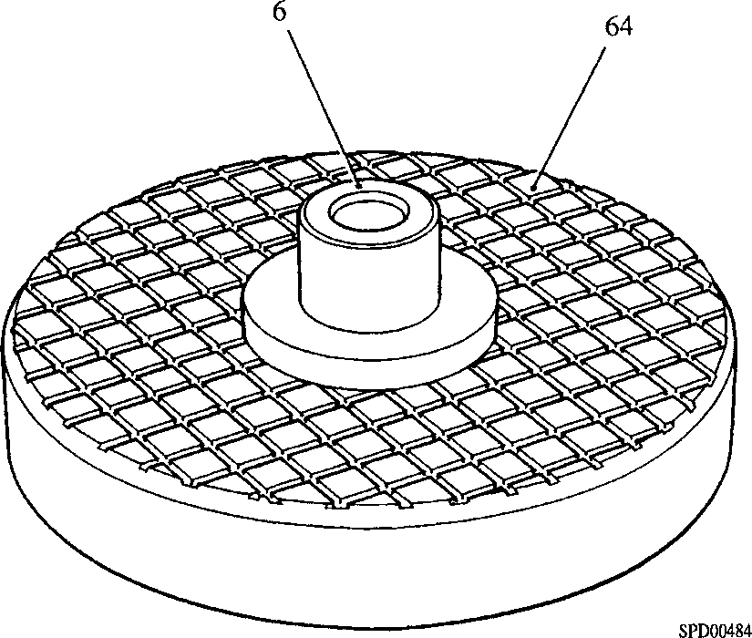6. Delivery valve seat

64. Lapping plate

Fig GF.4 Lapping plate, to restore mating face of delivery valve seat.

1. Tappet roller (23). Check the outer diameter of the roller, which runs on the engine driven fuel pump camshaft, for a regular unbroken smooth surface, ie free from flats, corrosion, cracks, scuffing marks or overheating. Check the inner diameter for scoring, fatigue cracking and wear. If any of these faults are apparent, a new roller should be fitted.
2. Roller pin (18). Very little wear occurs on the pin, but it can become 'ridged' if the inner diameter of the roller is excessively scored. Wear on the pin will occur on the loaded side. It is permissible to refit the pin 180° from its original position to even out the wear.
3. Tappet (24) and pump body (15). Examine for scoring or excessive wear.
4. Plunger spring (14). Examine spring for corrosion and distortion. If spring is corroded or distorted, or is outside the design parameters quoted below, fit a new spring.

Load at compressed length of 98 mm

Design 121 to 130 kg

Minimum permissible 111kg

1. Spring plates and circlip (25, 26 and 12). Examine upper spring plate (26), and lower spring plate (25) for wear and burring at the engagement point with pump plunger (13). Renew if suspect. Examine circlip (12) for tension. Renew if any loss of tension or wear is present.
2. Control rod (27) and control sleeve (11). Examine the teeth on both rod and sleeve for excessive wear. Check the plunger pin guide slot in the sleeve for wear and burring. Renew either or both components if suspect. Examine the control rod and its bore in the pump body for excessive wear.
3. Control rod oil seal (52). Check the seal for worn or damaged sealing lip and for hardening of the body material. Renew if suspect.

CHAPTER 5

ASSEMBLY

1. When assembling, care must be taken that all parts are scrupulously clean, coated with the appropriate oil (injector test oil for the pump barrel, plunger, delivery valve/seat and spring, and clean engine lubricating oil for the tappet assembly, plunger spring, spring plates, control sleeve and rod) and brought together without the use of cotton waste, rags or cloth wipes of any kind.
2. Fit the pump body to STPC fixture (63)(Fig GF.3).
3. If, due to damage, new studs have to be fitted proceed as follows:-
4. Remove old studs.
5. Clean tappings in pump body of old 'LOCTITE' using plug tap. Thoroughly degrease stud holes and longer threaded ends of new studs using 'Loctite Safety Solvent' or trichloroethane. Allow solvent to dry.
6. Apply a small quantity of 'Loctite 270' to longer threaded end of studs, and screw into pump body until they bottom. Finally tighten to a torque loading of 34 Nm (25 lbf ft). Allow approximately 3 hours for the 'Loctite' to cure.
7. Fit new 'O' ring (28)(Fig GF.14) to the groove in the pump body and smear with a small quantity of petroleum jelly.

NOTE When assembled it is essential the barrel locating slot is exactly aligned with the locating screw hole. The position of the locating slot can be approximated by centralising the barrel port through the spill plug hole.

1. Ensure that the locating slot in the barrel is aligned with the barrel locating screw hole in the body, fit the barrel and push down on to its seating.
2. Fit a new 'O' ring (39) to barrel locating screw (40), insert into the pump body, finger-tighten until the hexagon abuts the body and 'nip up' tight with a spanner.
3. Fit spill plug (41) together with a new copper washer (42) and tighten securely. Wire lock to the barrel locating screw.
4. Fit high pressure seal (7) and support ring (31) to delivery valve seat (6) - the chamfer on the bore of the high pressure seal to the delivery valve seat flange - and position the assembly in the pump housing.
5. Fit delivery valve (4) and spring (3).
6. Fit a new 'O' ring (32) and backing ring (65) to delivery valve holder (1). Apply a small quantity of petroleum jelly to the 'O' ring. Check spring peg (2) is in position.
7. Ensure that the delivery valve holder is positioned with the outlet connection above the fuel inlet port (8), locate the holder to the studs and insert into the body. Press steadily downwards until the holder is fully home.
8. THE METHOD OF TIGHTENING THE DELIVERY VALVE HOLDER SECURING NUTS IS CRITICAL. THE FOLLOWING PROCEDURE MUST BE FOLLOWED IF HIGH PRESSURE LEAKAGE IS TO BE AVOIDED.
9. Fit plain washers and nuts to the pump studs, applying PolyButylCuprysil (PBC) to the threads and nut pressure faces.

LIMITED RIGHTS LEGEND

a USE, DUPLICATION OR DISCLOSURE OF THIS INFORMATION WHICH IS THE PROPERTY

**14** OF GEC ALSTHOM DIESELS LIMITED BY THE U.S. GOVERNMENT OR BOLLINGER IS

SUBJECT TO THE RESTRICTIONS SET FORTH IN DOD FAR SUPP 252.227-7013 (a) 15.

68

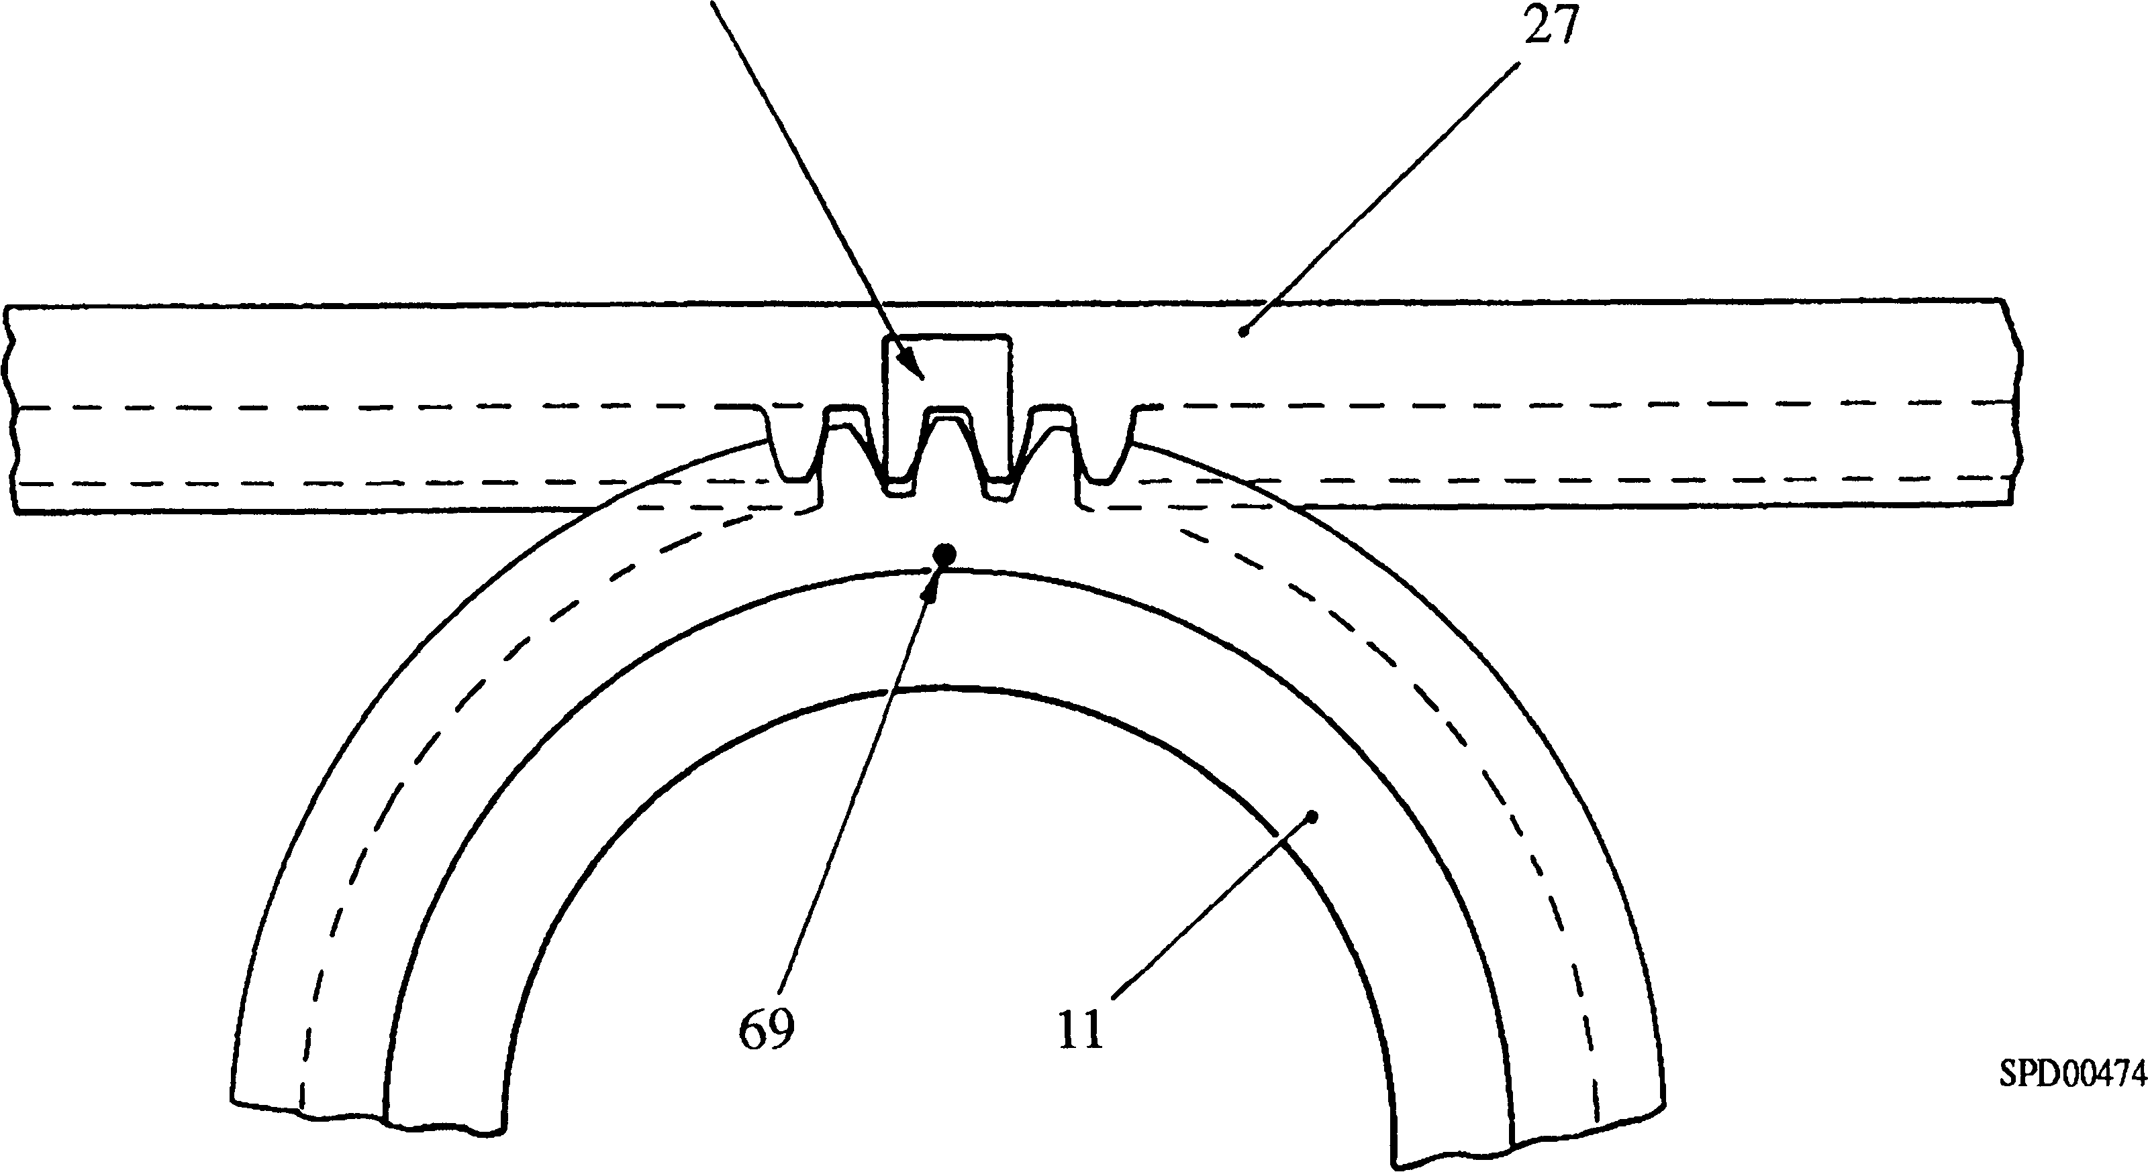

Key to Numbers.

1. Control sleeve 68. Positioning flat

27. Control rod 69. Mark on control sleeve

Fig GF.5 Meshing of control rod and sleeve.

1. Hand tighten the nuts in sequence while checking that the gap between the body and delivery valve holder is parallel to within 0.05 mm (0.002 in) as measured at the studs. This alignment must be maintained during the remainder of the tightening sequence.
2. Tighten the nuts in sequence by increments of not more than 27 Nm (20 lbf ft) until the final torque loading of 101 Nm (75 lbf ft) is reached.
3. Using a new joint (45), fit stop plate (46) to blank off the end of the control rod bore furthest away from the spill plug. Secure with plain washers and setscrews (48).
4. Insert control rod (27) with the tapped end outermost, centrally in the pump body.
5. Press a new oil seal (52) into retaining plate (53) with the open side of the seal to the plate recess.
6. Using a new joint (49), slide retaining plate (53) over control rod (27) and push it into contact with the pump body. Position the tapped hole uppermost.
7. Slide the centralising sleeve over the control rod and into the oil seal to centralise the seal/retaining plate assembly. Secure the retaining plate with plain washers and setscrews (51). DO NOT FIT pointer plate and shims (56) at this stage.
8. Remove the centralising sleeve.

NOTE If a new pump body, element assembly or tappet assembly has been fitted, a Stroke To Port Closure (STPC) test will be necessary. In such cases, if there is no pressurised oil feed available for the STPC test, the high pressure seal test should be left until after the STPC test.

1. Remove the pump from the STPC fixture and carry out the barrel 'O’ ring, barrel seating and high pressure seal tests as described in Chapter 6 - Static Tests.
2. Secure jacking screw fixture (61)(Fig GF.2) to the pump flange, and place the pump and fixture in an inverted position on the arms of support fixture (62).
3. Insert control sleeve (ll)(Fig GF.5) ensuring that the marked teeth on the control rod and sleeve are correctly aligned. The root of one tooth on the control sleeve is marked by a dot and the meshing teeth on the control rod by a positioning flat.
4. Place the upper spring plate (26)(Fig GF.14) in position and fit circlip (12). Ensure that the circlip is bedded firmly against the upper spring plate and then check control rod (27) for freedom of movement.
5. Place plunger spring (14) in position in the pump body. Engage lower spring plate (25) with the foot of plunger (13), and insert the plunger into barrel (29). Ensure that plunger locating pin (16) is in line with its slot in the control sleeve and that the spring plate is centred on the spring.
6. Place the roller assembly in tappet (24) and, from the locking screw side of the tappet, insert roller pin (18) until roller pin locating dog (58)(Fig GF.2) is flush with the opposite side of the tappet.
7. Insert the tappet assembly into the pump bore ensuring that locating dog is in alignment with the slot in the pump body. Swing jacking screw (60) into position over the tappet and screw pressure plate (59) down into contact with tappet (24).

NOTES 1 A screwdriver slot is machined in roller pin locating dog (58) to enable roller pin (18) to be turned to align the drilling for locking screw (21)(Fig GF.14) with the drilling in the tappet body.

2 It is probable that the tappet assembly will go solid before it is possible to engage the locating dog. This is caused by plunger locating pin (16)(Fig GF.14) not being in line with its slot in the control sleeve. To overcome this, unscrew the jacking screw half a turn, move the control rod to alter the position of the control sleeve slot and screw down the jacking screw. Repeat until the pin enters the slot, ie there is no resistance to jacking.

1. Carefully screw down the jacking screw, compressing the plunger spring until it is possible to slide locating dog into engagement with its slot in the pump body. Release the jacking screw, swing clear of the pump, and fit tabwasher (20), and locking screw (21) to lock the roller pin in the tappet body.
2. Check that the load required to move the control rod from any position in its travel range does not exceed 680 gf (1.5 lbf).

CHAPTER 6

STATIC TESTS

1. Barrel to Pump Housing'O'Ring Seal Test. (Fig GF.6)
2. Fit blanking plate (70), locating the dowel in the oil transfer drilling and securing the plate to the flange with the stud and knurled nut provided.
3. Fit a 3/s in. BSP blanking plug (75) and copper washer (76) to the fuel outlet port.
4. Push appropriate dummy plunger (73) into the barrel until it 'bottoms' on the delivery valve seat (6).
5. Hold inner knob (72), turn outer knob (71) clockwise to draw inner plunger (78) towards inner knob, compressing 'O' rings (77) and (79) to grip the barrel bore.
6. Connect an air supply of 5.5 bar (80 lbf/in2) to fuel inlet port (8)(V2 in BSP).
7. Invert the pump body, check that control rod (27) is still in a central position in the pump housing and fill the cavity formed by the pump body and barrel with clean test fuel oil to the level indicated (74). This ensures that the end of the barrel is covered by the test oil.
8. Turn on the air supply and check for bubbles. Air will be passed from the fuel gallery via the fuel drilling in the barrel to the barrel bore, a recessed portion of the plunger allowing air to pass to the lubricating oil drilling through the barrel which will in turn allow the air to pressurise one side of the barrel to pump body 'O' ring. If bubbles appear from between the barrel and pump housing, 'O' ring (28) has been damaged during assembly and will have to be renewed.
9. Turn off and disconnect the air supply. Invert the pump and drain off the test

oil.

1. Turn outer knob (71) anti-clockwise to release the pressure on the dummy plunger 'O' rings and withdraw the plunger from the barrel. Remove blanking plug (75).
2. Barrel to Pump Housing - Face Seal Test. (Fig GF.7)
3. Proceed as for Paragraph 6.1.1 and 6.1.2 above.
4. Push the appropriate dummy plunger (80) into the barrel until it 'bottoms' on delivery valve seat (6).
5. Hold inner knob (72) and turn outer knob (71) clockwise to draw the inner plunger towards the inner knob and compress 'O' rings (77) and (79) gripping the barrel bore.
6. Connect an air supply of 5.5 bar (80 lbf in2) to the fuel inlet port (8)(V2 in. BSP).
7. Check that the control rod is still in a central position in the pump housing and fill the cavity formed by the pump body and barrel with clean test oil until the end of the barrel is covered (74).

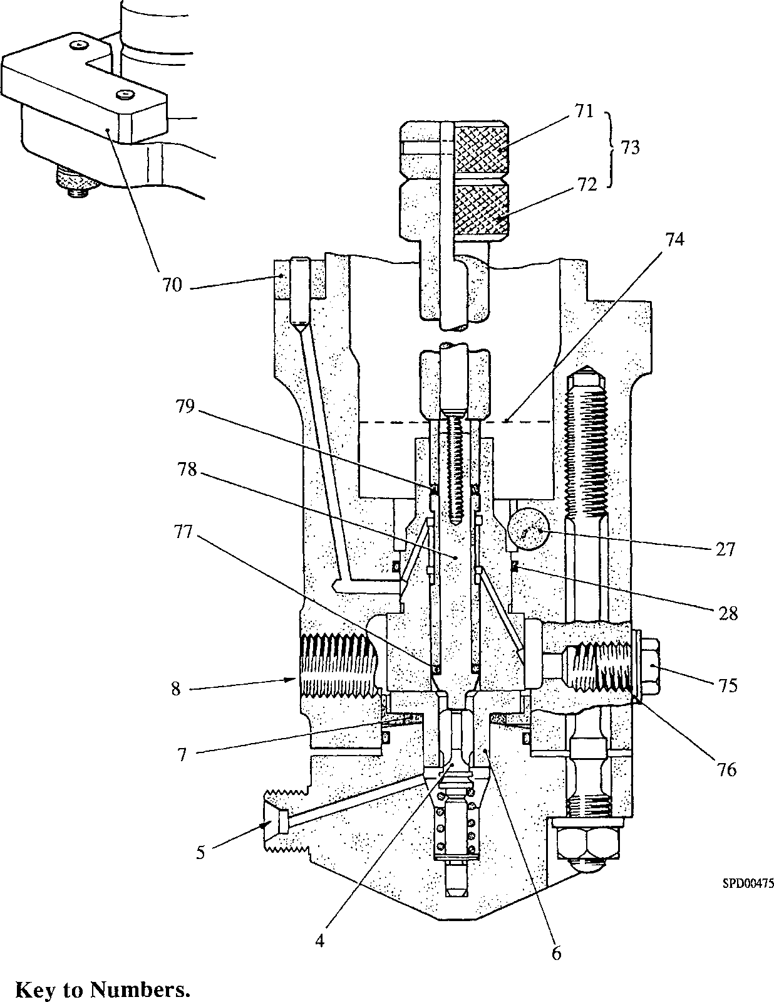

|  |  |  |  |
| --- | --- | --- | --- |
| 4. | Delivery valve | 72. | Inner knurled knob |
| 5. | Outlet to injector | 73. | Dummy plunger |
| 6. | Delivery valve seat | 74. | Test oil level |
| 7. | High pressure seal | 75. | Blanking plug 3/8 in. BSP |
| 8. | Fuel inlet port | 76. | Copper washer |
| 27. | Control rod | 77. | Dummy plunger 'O' ring |
| 28. | 'O' ring | 78. | Inner plunger |
| 70. | Blanking plate | 79. | Dummy plunger 'O' ring |
| 71. | Outer knurled knob |  |  |

**Fig GF.6 Dummy plunger fitted for barrel to pump body 'O' ring test and high**

**pressure seal test**

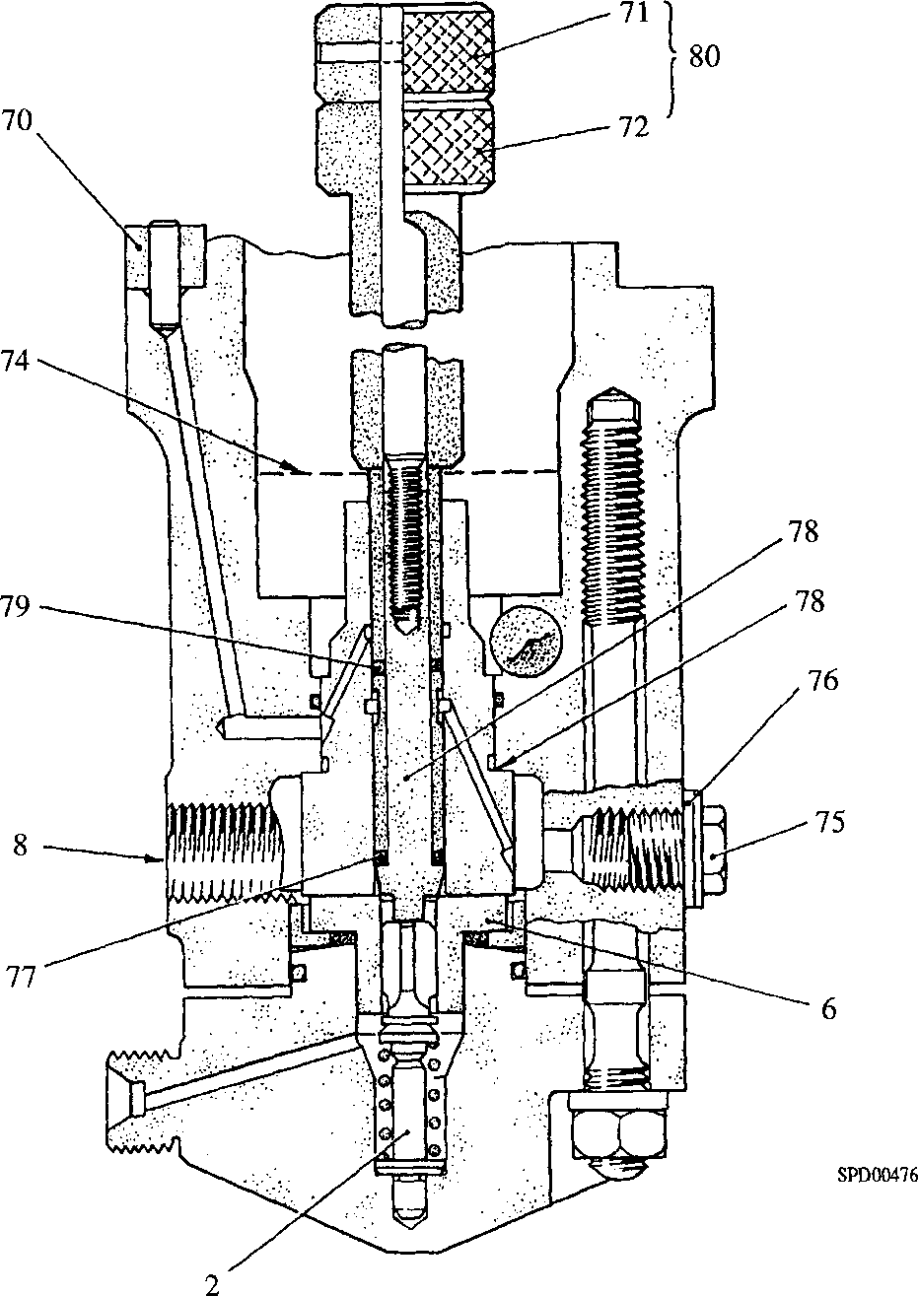

**Key to Numbers.**

75. Blanking plug 3/8 in. BSP 7 6. Copper joint washer

2. Spring peg

6. Delivery valve seat

8. Fuel inlet port

1. Blanking plate
2. Outer knurled knob
3. Inner knurled knob

74. Test oil level

1. Dummy plunger 'O' ring
2. Inner plunger
3. Dummy plunger 'O' ring
4. Dummy plunger
5. Barrel to pump body seal face

Fig GF.7 Dummy plunger fitted for barrel to pump body face seal test.

1. Turn on the air supply and check for bubbles. The air will pressurise fuel gallery, any leakage past the barrel to pump body face seal (81) passing to the barrel lubricating oil drilling and appearing as bubbles at the end of the barrel. If bubbles appear the pump will have to be dismantled and the sealing faces of the barrel and body examined for damage.
2. Turn off and disconnect the air supply. Invert pump and drain the test oil. Turn outer knob (71) anti-clockwise to release the pressure on the dummy plunger 'O' rings and withdraw the plunger from the barrel. Remove blanking plug (75).

|  |  |  |  |
| --- | --- | --- | --- |
| 63. | STPC fixture | 84. | Jacking screw handwheel |
| 82. | Dial Test Indicator | 85. | Ram adaptor |
| 83. | Setting piece | 86. | Gauging arm |

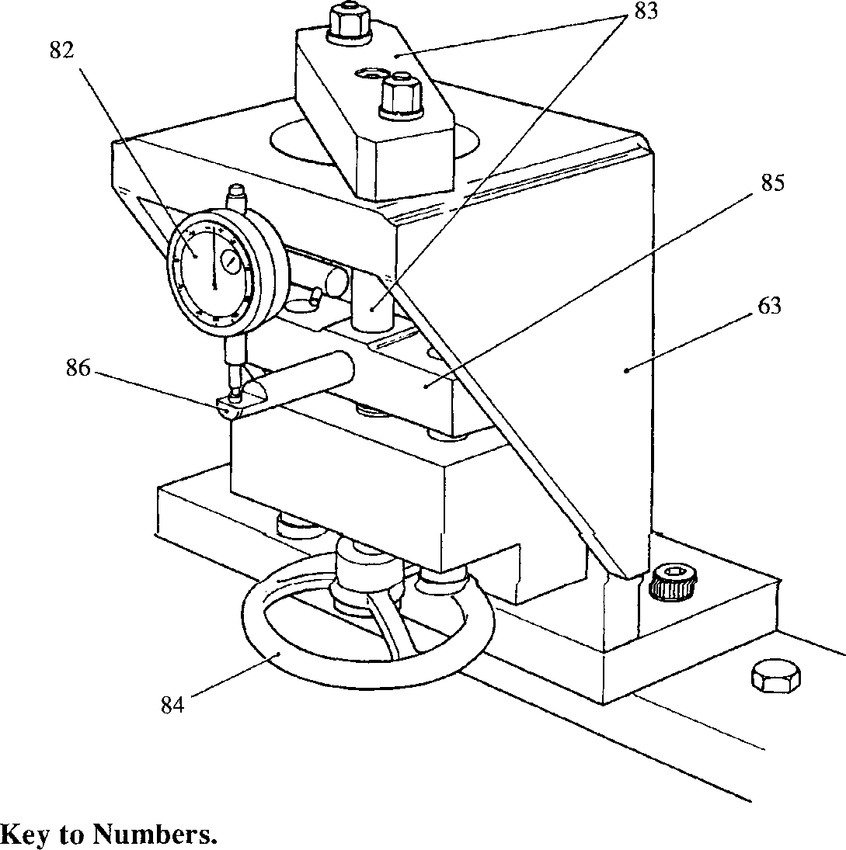Fig GF.8 STPC fixture with setting gauge.

**SPD00477**

1. Stroke to Port Closure Test. (Figs GF.8 and GF.9)

NOTE It is essential to carry out this test when any of the following components are renewed or replaced:- element assembly, pump body, lower spring plate, tappet, roller pin and tappet roller.

1. Bolt setting piece (83)(Fig GF.8) to STPC fixture (63).
2. Fit Dial Test Indicator (DTI)(82) ensuring that gauging arm (86) is in line with the indicator probe.
3. Rotate jacking screw handwheel (84) to raise ram adaptor (85) into firm contact with the setting piece. Set DTI to zero, lower ram adaptor and remove setting piece.
4. Fit the pump to the STPC fixture - WITHOUT SHIMS UNDERNEATH THE PUMP FLANGE - and bolt down securely (Fig GF.9).
5. Fit a 3/s in BSP blanking plug and copper washer to fuel return port (30)(Fig GF.16).
6. Fit spill pipe (88)(Fig GF.9) to the delivery valve holder outlet.
7. Connect a pressurised fuel oil supply to the pump inlet connection. A pressure of 10.34 ± 0.35 bar (150 ± 5 lbf/in2) is required to open the delivery valve. If such a supply is not available, proceed as follows:-
8. Remove the delivery valve holder and withdraw the delivery valve and spring. DO NOT disturb the delivery valve seat and high pressure seal.
9. Replace the delivery valve holder, complete with 'O' ring, and tighten the securing nuts EXACTLY as described in Paragraph 5.12. It is not necessary to tighten the nuts to the full torque loading quoted in Paragraph 5.12 for the purpose of the STPC test, a torque loading of 54 Nm (40 lbf ft) is sufficient.
10. Connect a fuel oil supply with a gravity head of not less that 0.61 m (2 ft) to the pump inlet connection.
11. Move the control rod to the 'FULL FUEL’ position, ie push into the pump to the limit of its travel.
12. Turn 'ON' the fuel supply to the pump; fuel will flow from the spill pipe.

NOTE Cessation of fuel flow must always be taken when turning the jacking screw UP, otherwise an incorrect measurement may be obtained. If the flow from the spill pipe does not cease, then the control rod and sleeve are incorrectly meshed.

Screw up jacking screw handwheel (84) until the fuel oil flow from the spill pipe JUST stops.

6.3.10

6.3.11

6.3.12

6.3.13

6.3.14

Check that dial gauge is reading between -0.12 mm and -0.77 mm. If outside limits, a new element must be fitted and the test repeated after Tests 6.1 and **6**.**2**.

The dial gauge reading is the difference from the nominal 4 mm STPC and is the shim thickness required between the cambox and pump when fitting the pump. Stamp this figure, as a minus reading omitting the decimal point and dimensional unit, on the pump flange. For example, a typical reading might be -0.35 mm, and -35 would be stamped on the pump flange to show that a shim thickness of 0.35 mm is required.

CHECK THE PUMP FLANGE FOR PREVIOUS MARKINGS AND CANCEL AS APPROPRIATE.

DO NOT REMOVE the pump from the fixture, disconnect the auxiliary fuel oil supply (or replace the delivery valve and spring if these have been removed) until the Dead Rack Travel Test (Paragraph 6.4) has been carried out.

.4 Dead Rack Travel Test.

NOTE It is essential to carry out this test if the STPC test has been carried out, and also if the mesh between the control rod and control sleeve has been disturbed.

1. Retaining the control rod in the 'FULL FUEL' position, screw UP the jacking screw until fuel flow JUST ceases.

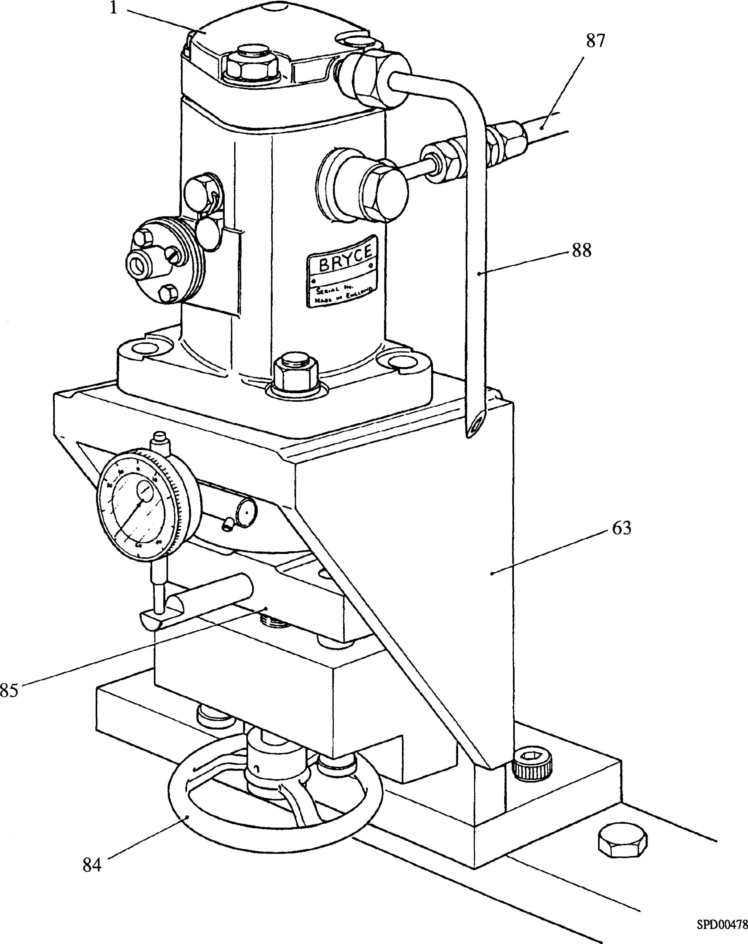

Key to Numbers.

|  |  |  |  |
| --- | --- | --- | --- |
| 1. | Delivery valve holder | 85. | Ram adaptor |
| 63. | STPC fixture | 87. | Fuel supply pipe |
| 84. | Jacking screw handwheel | 88. | Spill pipe |

Fig GF.9 Arrangement for checking spill cut-off point

1. Slowly draw the control rod out of the pump, ie towards the 'STOP' position until the flow restarts. This must occur before the control rod reaches the end of its travel. Refer to Figs GF.12 and GF.13 for minimum dimensions. If the flow does not start or restarts early, the control rod and sleeve are incorrectly meshed.

60

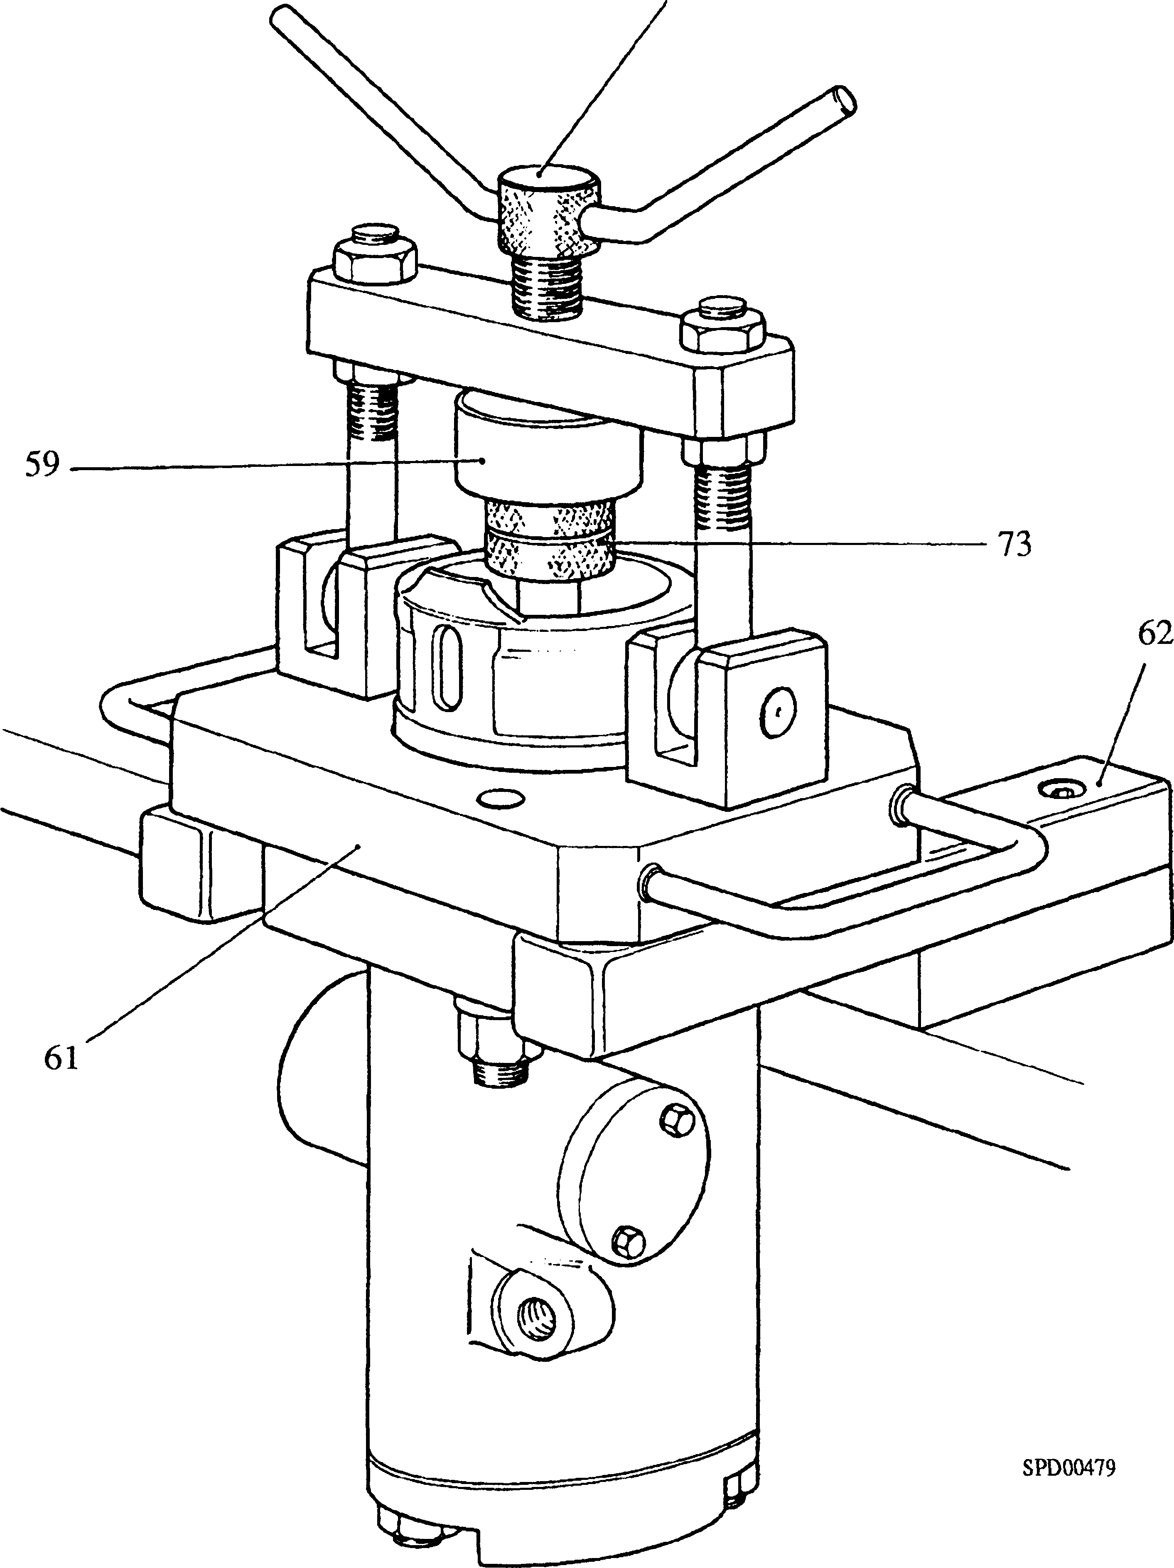

Key to Numbers.

|  |  |  |  |
| --- | --- | --- | --- |
| 59. | Pressure plate | 62. | Support fixture |
| 60.  61. | Jacking screw  Jacking screw fixture | 73. | Dummy plunger |

Fig GF.10 Arrangement of high pressure seal test.

1. If the test is satisfactory, disconnect the fuel oil supply and remove the spill pipe and the blanking plug.
2. If the delivery valve has been removed, refit the delivery valve and spring and tighten down the delivery valve holder EXACTLY in the manner and to the torque loading described in paragraph 5.12.
3. High Pressure Seal Test. (Fig. GF.10)

NOTE It is recommended that this test is carried out whenever the delivery valve holder has been disturbed. It should be noted that the test is carried out on a partially assembled pump.

1. Fit the pump to jacking screw fixture (61) and place in an inverted position on the arms of support fixture (62).
2. If the pump is in a fully assembled state, remove the tappet assembly plunger and return spring.
3. Insert dummy plunger (73)(Fig GF.6) into the barrel until it 'bottoms' on the delivery valve. Holding the inner knurled knob, turn the outer knob clockwise to lock the plunger in position.

CAUTION IT IS ESSENTIAL THAT THE DELIVERY VALVE IS HELD OFF ITS SEAT BY THE DUMMY PLUNGER DURING THIS TEST. CARE MUST THEREFORE BE TAKEN TO ENSURE THAT THE PLUNGER IS HELD IN FIRM CONTACT WITH THE DELIVERY VALVE SEAT WHILST LOCKING. FAILURE TO OBSERVE THIS PRECAUTION MAY RESULT IN BARREL DISTORTION.

1. Swing the jacking screw into position and screw down to to clamp the dummy plunger in position. The jacking screw must be tightened firmly, but care must be taken not to overtighten.
2. Connect outlet (101)(Fig GF.13) of High Pressure Trolley Set to the delivery valve holder. Adjust the Trolley Set to give a test pressure of 1551 bar (22,500 lbf/in2). Close isolating valve (99) and record the time taken for the pressure to drop by 34.5 bar (500 lbf/in2). For High Pressure Trolley Set operating instructions refer to Chapter 10.
3. If the time taken for the pressure drop is less than 30 seconds, a new high pressure seal should be fitted and the test repeated. On satisfactory completion of the test, relieve all pressure, disconnect the trolley from the pump, and remove the dummy plunger.
4. Directly following the pressure test, insert pump plunger (13)(Fig GF.14) into barrel (29) and ensure that it moves freely throughout the length of the barrel. If the plunger feels tight at the top of its stroke, plunger nipping is present, and if not resolve will cause damage to the pump. The remedy is to release the load on the delivery valve holder nuts and retighten as described in Paragraph 5.12. Repeat the High Pressure Seal Test. If the delivery valve holder nuts have been correctly tightened plunger nipping will have been eliminated.

CHAPTER 7

FUEL INJECTION PUMP CALIBRATION

General

7.1

7.2

7.3

7.4

7.5

7.6

Owing to variation in test equipment, it is impossible to state a specific fuelling for a control rod setting, and it is necessary to check the rig using a pre-calibrated 'Reference Pump' to establish a datum. This check must be carried out before any test and MUST BE REPEATED DAILY.

The 'Reference pump' must not be re-shimmed, stripped or interfered with in any way. It is essential to check the reference pump is of the correct build for the pump to be calibrated

After carrying out the Datum Test it is important that the pumps are tested against the Corrected Test Specifications.

***NOTE Pumps being tested, particularly the 'Reference Pump', should not be operated on the test rig for longer than is necessary to complete the required test. The reference pump should be returned to the manufacturer annually to be checked against a master pump.***

The tests are carried out on Rebuilt pumps to ensure that rebuilding has been correctly carried out or Service pumps to ensure that they are suitable for further running after normal service interval on the engine.

If any of the tolerances stipulated in the tests cannot be achieved, reference should be made to Table 7.1.

Settings. The following settings are applicable to all tests:-

7.7

Camshaft speed Fuel oil for test Fuel pressure Fuel temperature Lubricating oil Lubricating oil pressure Test Rig warm up

400 and 200 rev/min

Castrol Calibration 'C', or equivalent

3.7 to 3.9 bar (53 to 57 lbf/in2)

20 to 30°C

Shell Rotella X30 or equivalent 4.2 to 5.5 bar (60 to 80 lbf/in2)

7.7.1 The test rig must be warmed up before testing. A slave pump, ie a spare pump, should be set aside for this purpose. DO NOT USE THE REFERENCE PUMP FOR WARMING UP.

1. Fit a slave pump to the test machine cambox and connect the fuel feed and injection piping.
2. Wipe the end of the control rod and secure adjusting screw (90) and plate (92) (Fig GF.ll) to the end of the control rod using M8 capscrew (89).
3. Referring to Paragraph 7.6 set the lubricating oil and fuel pressures.
4. Start the test rig and set the camshaft speed.

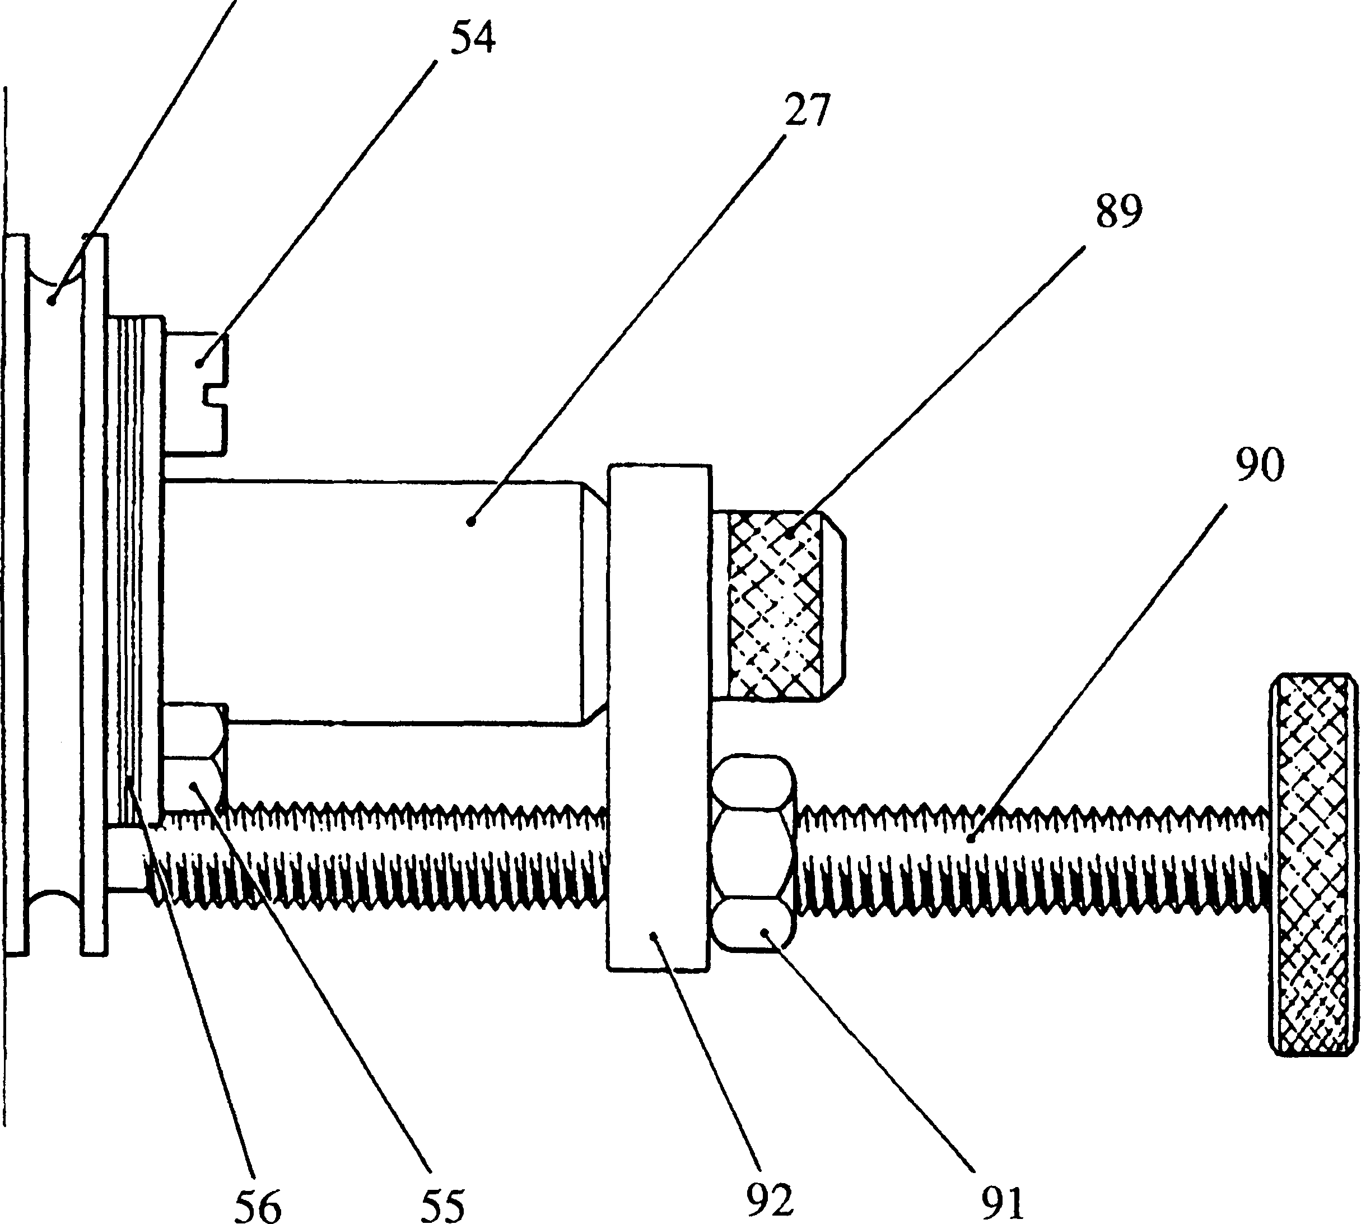

Key to Numbers.

|  |  |  |  |
| --- | --- | --- | --- |
| 27. | Control rod | 89. | Capscrew, M8 |
| 53. | Retaining plate | 90. | Adjusting screw |
| 54. | Cheesehead screw | 91. | Locknut |
| 55. | Setscrew | 92. | Adjusting screw plate |
| 56. | Pointer plate and shims |  |  |

Fig GF.ll Arrangement of control rod adjusting screw.

1. Open the valve in the fuel outlet return pipe and allow air to be purged from the system. Adjust the valve after approximately 30 seconds to maintain the fuel pressure.
2. Set the distance between adjusting screw plate (92) and pointer plate (56) with gauge 'W' and tighten locknut (91). Run the pump at this setting for approximately 10 minutes to warm up.
3. When the fuel has reached the correct temperature, stop the test rig, switch off the lubricating oil and fuel supplies, remove the fuel feed and injection piping, and the adjusting screw and plate. Remove the pump from the test rig.
4. If the fuel temperature drops below that specified, use the slave pump again to warm up the test rig.

TABLE 7.1 PUMP OUTPUT TOLERANCES

|  |  |  |  |  |
| --- | --- | --- | --- | --- |
| REFERENCE PUMP OD28946 | | | INJECTION PUMP  OD30539  (FCCAR180M008009) | |
| Test  No | Camshaft  rev/min | Gauge | No of  Injections | Output Relative to Reference Pump |
| Setting point output  145 to 152 cc |
| 1 | 400 | Setting Point 'W' | 400 | ±1 |
| 2 | 400 | 22 mm wide  -v | 200 | +4 |
| 3 | 400 | 16 mm wide  'X' | 200 | -2  ±4 |
| 4 | 400 | 26 mm wide  Y' |  | Zero (Dead rack) |
| 5 | 200 | 29.5 mm wide  'W' | 200 | +6 |
| 6 |  | 22 mm wide  Limit gauge |  | -1  'Z'  35 mm wide |

Datum Test.

1. Fit the Reference Pump to the test machine cambox and connect the fuel feed and injection piping.
2. Wipe the end of the control rod and secure adjusting screw (90) and plate (92)(Fig GF.ll) to the end of the control rod using M8 capscrew (89).
3. Referring to Paragraph 7.6 set the lubricating oil and fuel pressures.
4. Start the test rig and set the camshaft speed.
5. Open the valve in the fuel outlet (return) pipe and allow air to be purged from the system. Adjust the valve after approximately 30 seconds to maintain the oil feed pressure.
6. Set the distance between adjusting screw plate (92) and pointer plate (56) using gauge 'W' and tighten locknut (91).
7. Re-check fuel pressure, lubricating oil pressure, camshaft speed and gauge 'W' settings. Check fuel temperature.
8. Measure and record the output for 400 injections of the pump.
9. Reset the control rod using gauge 'V' (See Chapter 9) and measure and record the output for 200 injections of the pump.
10. Reset the control rod using gauge 'X' and measure and record the output for 200 injections of the pump.
11. Stop the test rig, switch off the lubricating oil and fuel supplies, remove the fuel feed and injection piping, and the adjusting screw and end plate. Remove the pump from the cambox.

7.9 Pump To Be Tested.

1. Fit pump to test machine cambox and connect fuel feed and injection piping.

|  |  |
| --- | --- |
| 7.9.2 | Wipe control rod end and secure adjusting screw (90) and plate (92) (Fig GF.ll) to end of the control rod with M8 capscrew (89). |
| 7.9.3 | Referring to Paragraph 7.6 set lubricating oil and fuel pressures. |
| 7.9.4 | Start test rig and set camshaft speed. |
| 7.9.5 | Open the valve in fuel outlet (return) pipe and allow air to be purged from the system. Adjust valve after approximately 30 seconds to maintain fuel pressure. |
| 7.9.6 | Set control rod position by adjusting screw (90) until the pump output approximates that obtained with the Reference Pump at gauge 'V' setting. Tighten the locknut. Run the pump at this setting, dry thoroughly and examine for leaks. Rectify any leakage before proceeding with further testing. |
| 7.9.7 | Reset the control rod by means of the adjusting screw until the pump output is identical with that obtained from the Reference Pump using gauge 'W'. THE OUTPUT TOLERANCE IS ± 1 cm3 FOR 400 INJECTIONS (See Table 7.1). |
| 7.9.8 | Insert gauge 'W' against retaining plate (53) and measure the distance from the gauge to adjusting screw plate (92). This distance minus the thickness of the pointer plate is the thickness of shims required. |
| 7.9.9 | Fit the necessary shims and pointer plate to the retaining plate and secure with cheesehead screw (54) and setscrew (55). |
| 7.9.10 | Unlock adjusting screw and reset control rod position using gauge 'V' between the pointer plate and adjusting screw plate. Lock in this position. Measure and record the output for 200 injections of the pump and compare with Table 7.1. |
| 7.9.11 | Reset control rod using gauge 'X', measure and record the output for 200 injections of the pump and compare with Table 7.1. |
| 7.9.12 | Set the control rod with gauge 'Y' check that there is zero output. |
| 7.9.13 | Reduce rig speed to 200 re/min, reset control rod using gauge 'W', record output for 200 injections of the pump and compare with Table 7.1 |
| 7.9.14 | Withdraw the control rod from the pump as far as possible, ie towards the 'No Fuel’ position until the mechanical stop is contacted and check that it is possible to insert gauge 'Z' between the pointer plate and the adjusting screw |

plate. If the gauge cannot be inserted refer to Table 7.2.

7.10.14 Stop the test rig, switch off the lubricating oil and fuel supplies, disconnect

|  |  |
| --- | --- |
| 7.10.15 | the fuel feed and injection piping and remove the adjusting screw and end plate. Remove the pump from the cambox.  Check that the force required to move the control rod from any point in its travel does not exceed 680 grams (1.5 lbf). |
| 28 | LIMITED RIGHTS LEGEND  USE, DUPLICATION OR DISCLOSURE OF THIS INFORMATION WHICH IS THE PROPERTY  OF GEC ALSTHOM DIESELS LIMITED BY THE U.S. GOVERNMENT OR BOLLINGER IS  SUBJECT TO THE RESTRICTIONS SET FORTH IN DOD FAR SUPP 252.227-7013 (a) 15. |

TABLE 7.2 FAULT FINDING - FUEL INJECTION PUMP TESTING.

|  |  |  |
| --- | --- | --- |
| FAULT | POSSIBLE CAUSE | REMEDY |
| Reference Pump output too high or too low | Faulty test nozzle | Fit a new test nozzle |
| Test Rig lubricating oil pressure varies by more | Defective gauge | Check rig against Master gauge |
| than 0.69 bar (10 lbf/in2) | Pump incorrectly | Remove pump and check that grub- |
|  | assembled | screw (19)(Fig GF.16) has been fitted. Fit new roller pin if necessary |
| Force required to move | Damaged or hardened | Remove retaining ring assembly and |
| control rod exceeds | control rod oil seal | check movement. If loading is |
| 680 grams (1.5 lbf) | Bent control rod, damaged | reduced, fit a new seal.  Dismantle lower half of pump and |
|  | control sleeve or burred | inspect to establish cause. Renew |
|  | teeth | damaged parts. |
| Limit gauge 'Z' |  | Check minimum position of control |
| cannot be inserted |  | rod stand-out at which zero output is achieved, test rig running at 400 rev/min 200 injections. Providing this position is a minimum of 5.5 mm away from mechanical stop the pump is acceptable. If less, check pump for correct assembly and possible renewal of the element |
| Impossible to match | Incorrect pump | Check mark on control sleeve aligns |
| pump on test to | assembly | with positioning flat on control rod. |
| reference pump at gauge |  | If teeth are wrongly meshed,withdraw |
| settings 'V' and 'X' or to obtain zero output at |  | sleeve and re-mesh correctly |
| gauge setting 'Y' | Element assembly worn | Fit new element assembly. Rebuild pump carrying out all tests. |
| External leakage from |  | Determine source of leak and fit |
| pump |  | new joint or seal. If from high pressure seal, fit new seal and carry out High Pressure Seal Test - Paragraph 6.5. |

CHAPTER 8

FITTING

NOTE All joints and ’O' rings must befitted dry.

1. Fit new 'O' rings (113)(Fig GF.14), coated with petroleum jelly to their grooves in the fuel pump cambox.
2. Fit new 'O' rings (109) and (111) to oil transfer ferrule (110) and fit ferrule to the fuel pump cambox. 'O' ring (111) fitted to the lower end of the ferrule is smaller than 'O' ring (109) fitted to the upper end.
3. Check the thickness of laminated shim (112). Shim thickness required for each fuel injection pump is stamped on the injection pump flange, eg if a number such as -25 is found, then a shim thickness of 0.25 mm is required. Peel off the 0.05 mm laminations to obtain the correct thickness. Place the shim in position on the cambox.
4. Rotate the fuel pump camshaft to present the back of the cam.
5. Screw philidas nut (124) on to adjusting screw (122). Fit thrust washer (123), bellows (126), and adaptor (125) to the adjusting screw, and fit to the end of control rod (27). DO NOT OVERTIGHTEN.
6. Check that forked end lever (120) is removed. If necessary, release return springs (119) and remove the lever.
7. Hold longitudinal control shaft (118) as far as possible towards 'NO FUEL' by means of the hand lever. Push control rod (27) as far as possible into the fuel injection pump to clear spherical end lever (121).
8. Insert the pump into the cambox ensuring that the oil transfer ferrule (110) is correctly engaged. Secure with plain washers (115) and philidas nuts (116). Tighten to the torque loading quoted in Section C E.
9. Fit forked end lever (120) and connect return springs (119).
10. Move pointer (107) to the gauge position on indicator scale (105), and insert setting pin (108) through the pointer to locate with the reamed hole in setting block (106).
11. Peel bellows (126) back clear of adaptor (125). Adjust the length of control rod (27) by means of adjusting screw (122) until gap gauge (127) is a sliding fit between the adaptor and pointer plate (56). Make certain that the gap gauge is between the adaptor and the pointer plate and NOT between the adaptor and retaining plate (53). Tighten the philidas nut and re-check.
12. Remove the gap gauge and setting pin (108). Refit bellows (126).
13. CHECK THE CONTROL LINKAGE AS FOLLOWS:-
14. Check that adjusting screw (122) moves with spherical end lever (121), ie, that control rod (27) is not jamming.
15. Check longitudinal control shaft (118) for freedom of movement between maximum and minimum fuel stops.
16. Moving the linkage at the governor lever, check that that the control shaft pointers (107) on both banks can be moved to 'O' an indicator scale (105).

CAUTION AFTER SETTING, NO ADJUSTMENT OF INDIVIDUAL FUEL INJECTION PUMPS IS PERMITTED.

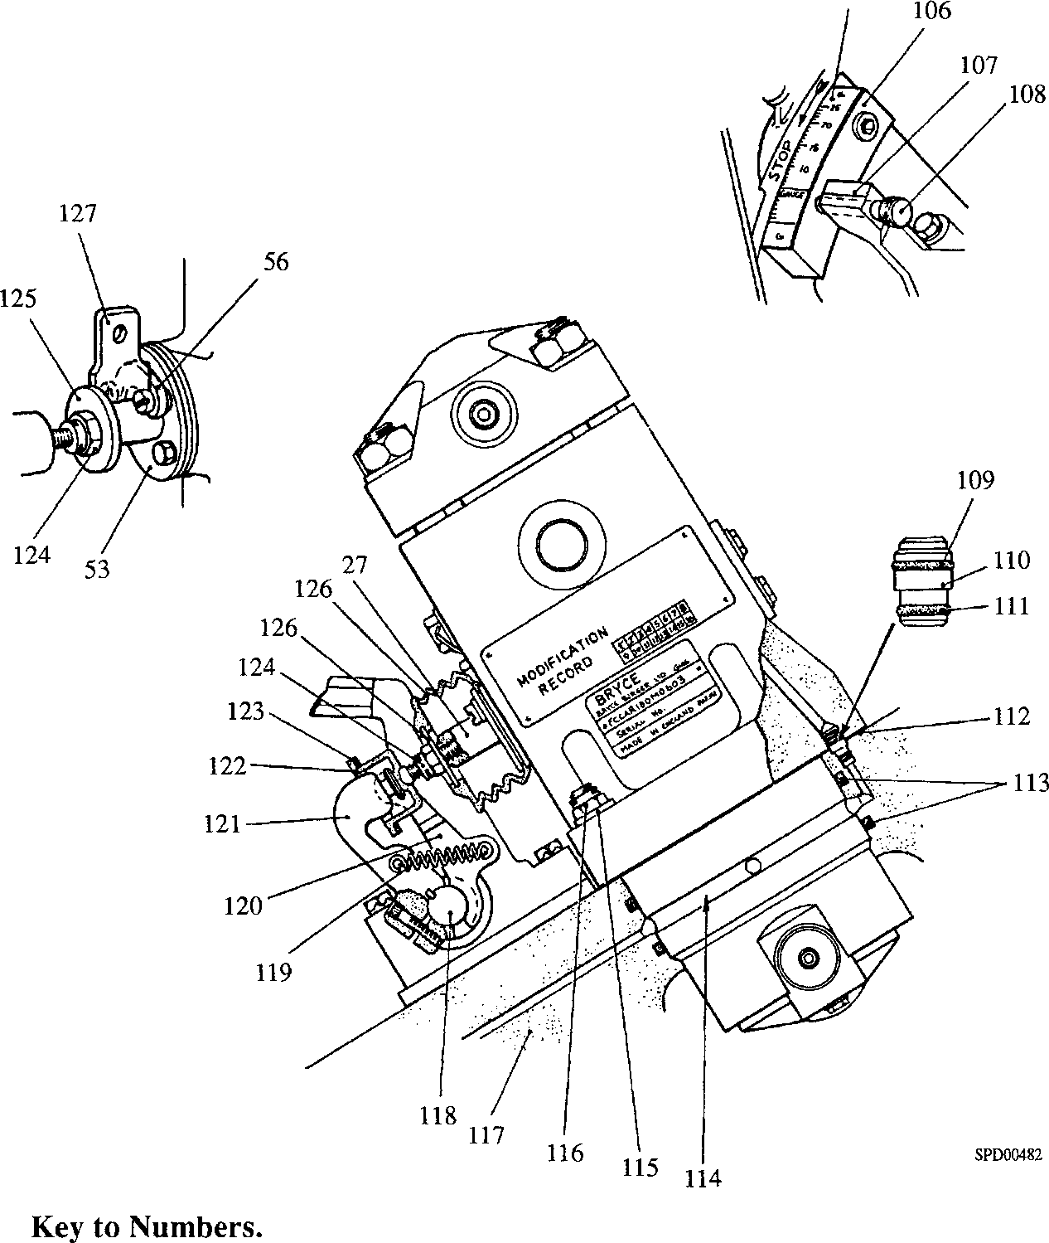

|  |  |  |  |
| --- | --- | --- | --- |
| 27. | Control rod | 115. | Plain washer |
| 53. | Retaining plate | 116. | Philidas nut |
| 56. | Pointer plate and shims | 117. | Fuel pump cambox |
| 105. | Indicator scale | 118. | Longitudinal control shaft |
| 106. | Setting block | 119. | Return spring |
| 107. | Pointer | 120. | Forked end lever |
| 108. | Setting pin | 121. | Spherical end lever |
| 109. | 'O' ring | 122. | Adjusting screw |
| 110. | Oil transfer ferrule | 123. | Thrust washer |
| 111. | 'O' ring | 124. | Philidas nut |
| 112. | Laminated shim | 125. | Adaptor |
| 113. | 'O' rings | 126. | Bellows |
| 114. | Oil supply groove | 127. | Gap gauge |

**Fig GF.12 Fuel injection pump removal and fitting.**

CHAPTER 9

SPECIAL TOOLS.

The following special tools and fixtures are necessary for fuel injection pump maintenance and servicing. Standard workshop tools are not included.

NOTE These tools are only shown in the Illustrated Parts List if they have been ordered as part of the contract.

|  |  |  |
| --- | --- | --- |
| DESCRIPTION | PART NO PAXMAN (BRYCE) | USE |
| Jacking screw fixture | OD28948/06  (75/634) | ( For removal and fitting of pump tappet,  (lower spring plate plunger spring, upper ( spring plate, circlip and control sleeve ((Fig GF.2)  (  ( To retain dummy plunger in position ( during the high pressure seal test |
| Support fixture | OD28948/07  (75/635) | Bench mounted fixture to carry jacking screw fixture complete with pump (Fig GF.2) |
| Stroke to Port Closure (STPC) fixture | OD28948/05  (75/633) | ( Pump mounting whilst working on top end ( of pump, ie delivery valve holder and valve (etc. (Fig GF.3)  (  ( When fitted with a dial indicator gauge, used ( for determining the stroke to port closure for ( cambox shimming (Figs GF.8 and GF.9) |
| Centralising sleeve | OD28948/11  (75/647) | To centralise retaining plate and seal to control rod during assembly |
| Blanking plate | OD28948/03  (75/594) | To blank off lubricating oil drilling in pump body during pressure testing (Fig GF.6) |
| Dummy plunger | OD28948/01 (75/591) | ( When pressure testing 'O' ring seal between ( barrel and pump body (Fig GF.6)  (  ( When testing high pressure seal using (jacking screw fixture |
| Dummy plunger | OD28948/02  (75/592) | When testing face seal between barrel and pump body (Fig GF.7) |
| Setting piece | OD28948/08  (75/636) | Setting STPC fixture for determining stroke to port closure for cambox shimming (Fig GF.8) |
| Spill pipe | OD28948/09  (75/639B) | To accurately indicate the end of fuel flow at port closure (Fig GF.9) |
| High pressure trolley set | OD28948/04  (75/617B) | To provide a hydraulic pressure of 1551 bar (22,500 lbf/in2)(Fig GF.15) |

|  |  |  |
| --- | --- | --- |
| DESCRIPTION | PART NO PAXMAN (BRYCE) | USE |
| High pressure pipe | OD28948/10  (75/640B) | To provide a connection between the high pressure trolley set and fuel injection pump under test |
| Reference Pump | OD28946  (FCCAR180M0809) | For checking test machine before calibrating pumps |
| Test Machine | OD30312 | Hartridge series 3000 |
| Cambox assembly | OD28949/01  (75/616) | For mounting to test machine with the correct camshaft for pump operation |
| Holder service tool  Test nozzle  Pressure | OD28949/02  (75/662)  OD28949/03  (75/679) | Nozzle holder for test machine,  For use with Nozzle holder (Setting  275 ±1 bar) |
| Injection pipe | OD28949/04 (75/618B) | For connecting pump on test to test machine injector (3 mm bore x 10 mm OD x 455 mm long [with Ermeto fittings]) |
| Adjusting screw assembly | OD28949/10  (75/614) | For adjusting the position of the control rod during calibration test (Fig GF.ll) |
| Setting gauge 'V' | OD28949/05  (75/615V) | (  (  (  (  ( ±For setting the pump control rod during ( pump testing and calibration (  (  (  (  ( |
| Setting gauge 'W'  Setting gauge 'X' | OD28949/06 (75/615 W)  OD28949/07  (75/615X) |
| Setting gauge 'Y' | OD28949/08 (75/615 Y) |
| Setting gauge 'Z' | OD28949/09 (75/615Z) | ( For checking the pump control rod setting ( after pump testing and calibration |
| Setting pin when | Y3J70878A | To locate the longitudinal control shaft setting fuel injection pump control rod (Fig GF.12) |
| Gap gauge | Y3J70661 | To set the length of control rod with longitudinal shaft in the 'gauge' position (Fig GF.12) |

CHAPTER 10.

OPERATION OF HIGH PRESSURE TROLLEY SET.

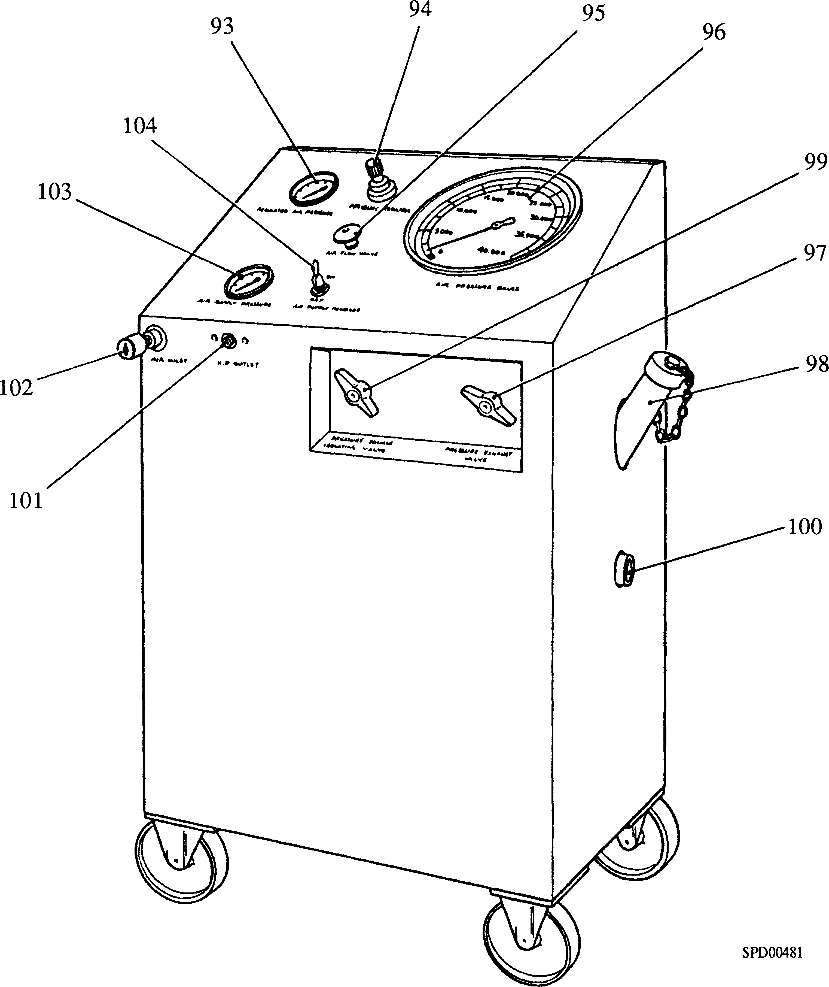

Key to Numbers.

|  |  |  |  |
| --- | --- | --- | --- |
| 93. | Gauge - regulated air supply | 99. | Pressure source isolating valve |
| 94. | Pressure regulator | 100. | Sight glass hydraulic oil level |
| 95. | Air flow valve | 101. | High pressure outlet connection |
| 96. | Gauge - test pressure | 102. | Air inlet connection |
| 97. | Pressure exhaust valve | 103. | Gauge, air inlet pressure |
| 98. | Hydraulic oil filler | 104. | Air supply switch, ON/OFF |

Fig GF.13 High pressure trolley set.

1. Check the level of the hydraulic oil in sight glass (100)(Fig GF.13). Top up if necessary via filler (98).
2. Check that the trolley set controls are positioned as follows:-
3. Air supply switch (104), 'OFF
4. Air flow valve (95), fully closed.

NOTE The pressure regulator is fitted with a locking mechanism. Pull up to release, push down to lock.

1. Pressure regulator (94), released, rotated fully anti-clockwise and locked.
2. Pressure source isolating valve (99), fully closed.
3. Pressure exhaust valve (97), fully closed.
4. Connect a suitable air supply with a minimum pressure of 5.5 bar (80 lbf/in2) to inlet connection (102); the air pressure at the inlet is shown on pressure gauge (103).
5. Check that the fuel injection pump has been correctly prepared for testing as detailed in Paragraph 6.5.1 to 6.5.4 inclusive and connect the high pressure outlet (101) to the pump delivery valve holder.
6. Re-check that pressure exhaust valve (97) is fully closed and open the pressure source isolating valve (99).

NOTE Air flow valve (95) controls the rate of increase of the test pressure.

Care must be taken when approaching the required test pressure, to reduce the rate of increase, to avoid overshooting the required pressure and possible damaging the pump barrel or the pump high pressure seal.

1. Switch 'ON' air supply switch (104), open air flow valve (95) and raise the test pressure by pulling up and rotating pressure regulator (94) clockwise. The air pressure from the regulator is shown on gauge (93) whilst the test pressure is shown on gauge (96).
2. When the required test pressure has been attained, lock pressure regulator (94) in position by pressing down on the knob, close the pressure source isolating valve (99) and switch 'OFF air supply switch (104).
3. Any leakage, due to a defective high pressure seal, can be observed on pressure gauge (96).

CAUTION PRESSURE EXHAUST VALVE (97) MUST BE RELEASED GRADUALLY TO AVOID A SUDDEN PRESSURE DROP WHICH MAY DAMAGE THE TEST PRESSURE GAUGE (96).

1. When the test has been completed, release the pressure by means of the pressure exhaust valve (97).
2. Rotate pressure regulator (94) anti-clockwise to the stop position and release the high pressure pipe from the fuel injection pump.
3. If tests are to be carried out on a number of pumps, the pressure regulator should be locked at the test pressure position and the pressure raised by operating air supply switch (104) and air flow valve (95). If this procedure is adopted, refer to the NOTE preceding Paragraph 10.6.

LIMITED RIGHTS LEGEND

USE, DUPLICATION OR DISCLOSURE OF THIS INFORMATION WHICH IS THE PROPERTY Q C

OF GEC ALSTHOM DIESELS LIMITF1D BY THE U.S. GOVERNMENT OR BOLLINGER IS **3** *7

SUBJECT TO THE RESTRICTIONS SET FORTH IN DOD FAR SUPP 252.227-7013 (a) 15.

Key to Numbers.

|  |  |  |  |
| --- | --- | --- | --- |
| 1. | Delivery valve holder | 30. | Protective plug, fuel return port |
| 2. | Spring peg | 31. | Support ring |
| 3. | Delivery valve spring | 32. | 'O’ ring |
| 4. | Delivery valve | 33. | Stud |
| 5. | Protective cap - outlet to injector | 34. | Special washer |
| 6. | Delivery valve seat | 35. | Nut |
| 7. | High pressure seal | 36. | Fuel inlet port |
| 8. | Blanking plug - fuel inlet port | 37. | Lubricating oil groove |
| 9. | Control helix groove | 38. | Supply drilling |
| 10. | Fuel collection groove | 39. | ’O' ring |
| 11. | Control sleeve | 40. | Barrel locating screw |
| 12. | Circlip | 41. | Spill plug |
| 13. | Plunger | 42. | Copper washer |
| 14. | Plunger spring | 43. | Fuel spill port |
| 15. | Pump body | 44. | Control rod venting |
| 16. | Plunger locating pin | 45. | Joint |
| 17. | Oil drilling | 46. | Stop plate |
| 18. | Roller pin | 47. | Plain washer |
| 19. | Grubscrew | 48. | Setscrew |
| 20. | Tabwasher | 49. | Joint |
| 21. | Locking screw | 50. | Plain washer |
| 22. | Retard helix groove | 51. | Setscrew |
| 23. | Tappet roller | 52. | Oil seal |
| 24. | Tappet | 53. | Retaining plate |
| 25. | Lower spring plate | 54. | Cheesehead screw |
| 26. | Upper spring plate | 55. | Setscrew |
| 27. | Control rod | 56. | Pointer plate and shims |
| 28. | 'O' ring | 65. | Backing ring - for 'O’ ring |
| 29. | Barrel -element assembly |  |  |

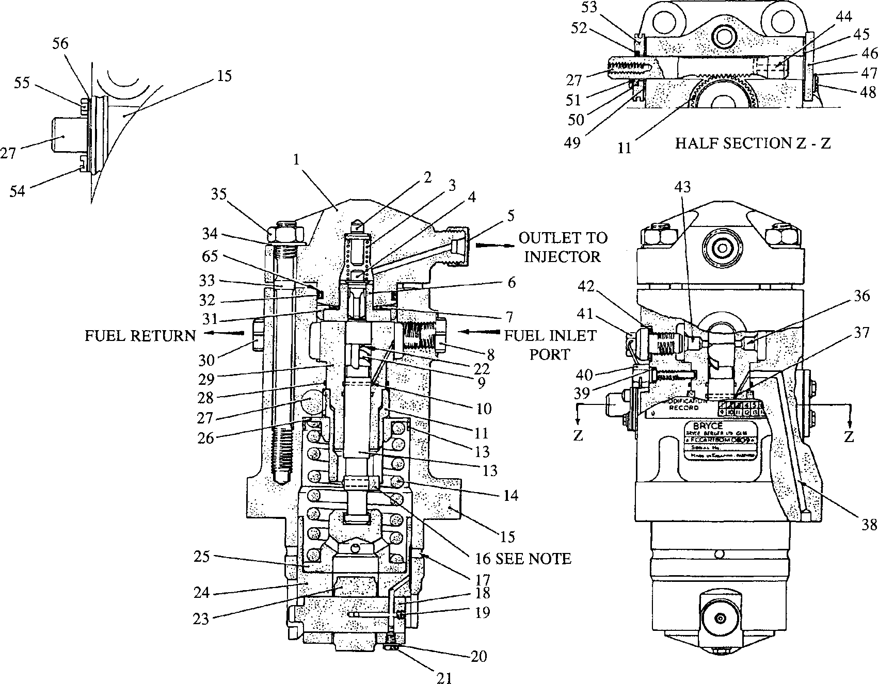

200GF015

<T>

ARRANGEMENT OF POINTER PLATE AND SHIMS

**spd00486**

NOTE

FOR CLARITY, PLUNGER (13) AND  
LOCATING SLOT IN CONTROL  
SLEEVE (11) HAVE BEEN  
ROTATED THROUGH 90° FROM  
TRUE ASSEMBLY POSITION

n,

**E**

**3**

**a.**

s

a>

**3**

o

W)

E

**>, W3**

1. a: w w
2. o •

***m***

£ as «r

g|a

£ S o,

**\*§£ © U »**

| § O <

g 3 o * **o! a**

BO"!$ W 2 © ® w Z > H - U £

s « s * g £ H P « H £ g

0 Q ?*

s s “ § g s «

§«p **« w y**

c w 2

B! a * ® ® w 5 S * Sow

**HS\*** < H H

ggB

gs§

P O 55